Date: June 18th 2019

ISLE OF MAN POST OFFICE HONOURS ILLIAM DHONE WITH ‘AGE OF REBELLION’ STAMPS

MANX HISTORY NARRATED ON A SET OF SIX STAMPS

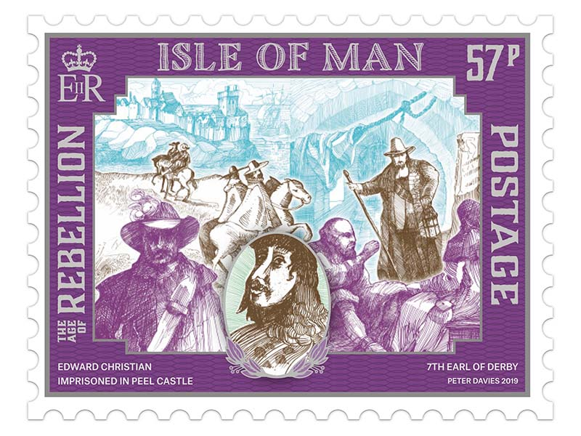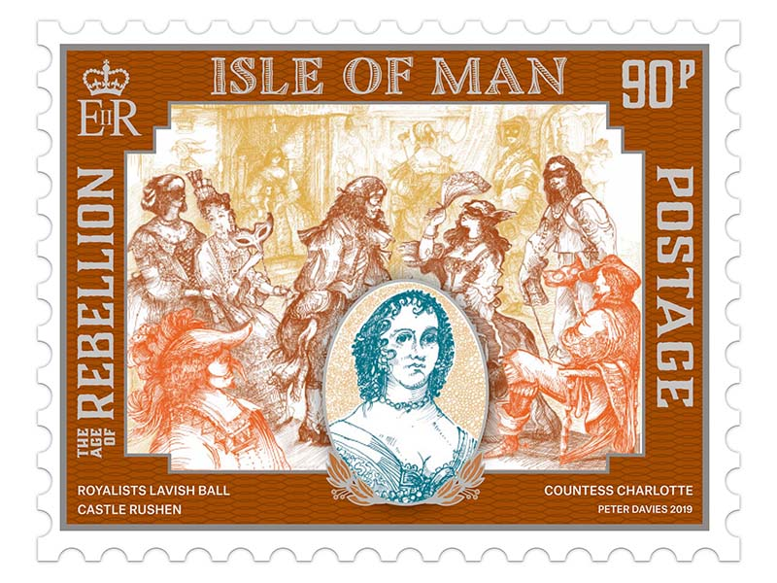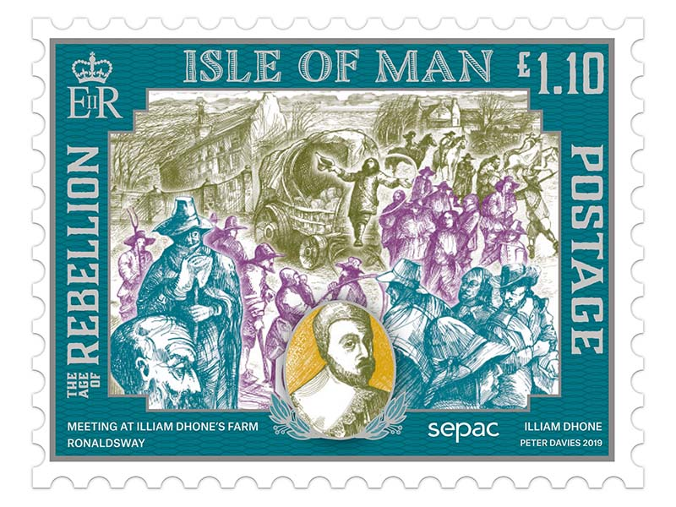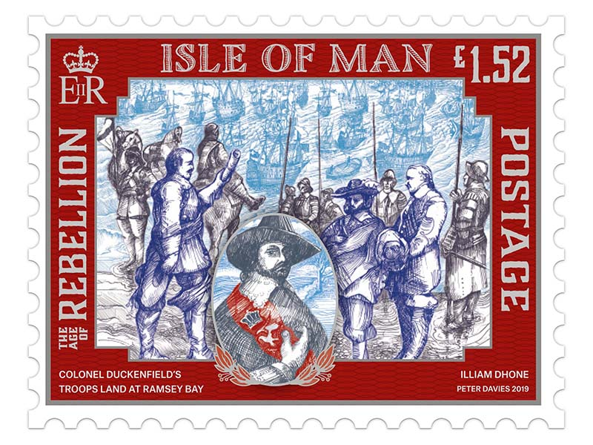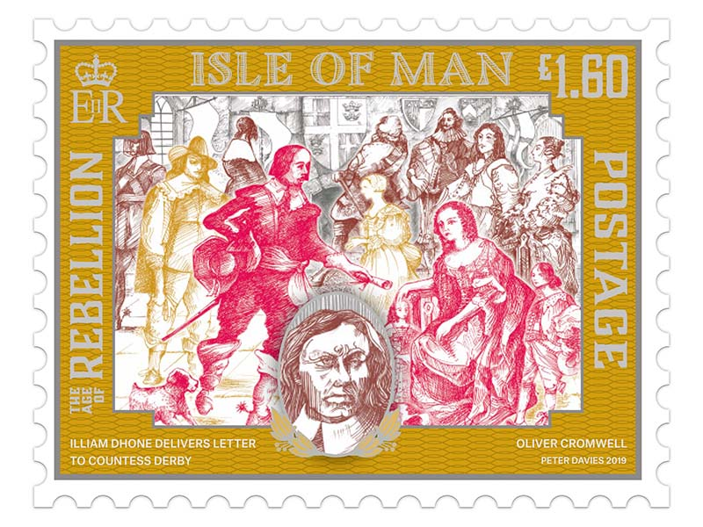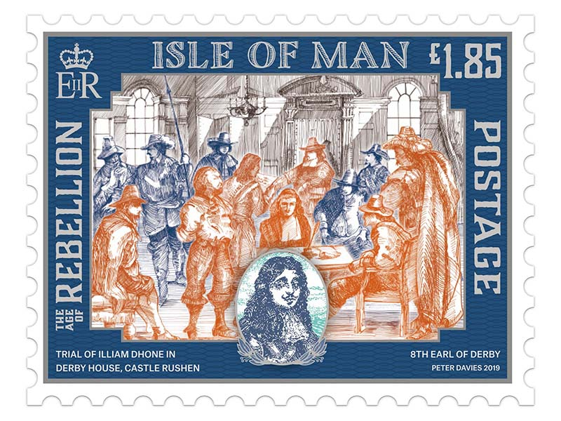

Isle of Man Post Office is pleased to spotlight this most tempestuous period in Manx history with a set of six stamps to be issued on July 1st 2019.

The 17th century was a troubled time for the Isle of Man. The Island was ruled and owned by the Stanley family of Knowsley in Lancashire, and between 1627 and 1651 it was James Stanley, the 7th Earl of Derby, who was in control. There was unrest from the very start of his rule: the Manx people objected to paying the taxes imposed on them by the Church. Furthermore, the Earl had decided to change the ancient system which allowed a tenant farmer to pass his tenancy on to his son. The Earl put an end to that and brought great uncertainty to Manx farmers.

The stamps focus on two members of a prominent Manx family, the Christians, who played a crucial part in the risings against the Earl and his wife: Edward Christian, son of the vicar of Maughold, who had reached an important position in the Earl’s administration as head of the militia, but set up a military camp at which he made the men take an oath of loyalty to him rather than the Earl. Among the many things he proposed was that the Members of the House of Keys should be elected by the people and not appointed by the Earl. For this and other treasonable ideas he was imprisoned in Peel Castle and died there in 1661.

Meanwhile another family member, William Christian, also a high officer in the Earl’s employment, started another rebellion. He was considered a traitor by the Stanleys but a patriot by many of the Manx for his actions in surrendering the Island to the Parliamentary troops during the Civil War. A trial was held in Castle Rushen at which Christian refused to plead, and so he was sentenced to death and executed at Hango Hill in January 1663. He became a hero to the Manx people and was nicknamed Illiam Dhone, or Brown William, on account of the colour of his hair.

Mark Kermode, Chairman of MecVennin said: "The Isle of Man Post Office is to be commended for helping to re-establish the good name of William Christian / Illiam Dhone with this stamp issue and supporting literature. Without him, the Isle of Man would now be very a different place. It’s a timely reminder that his bravery and ultimate sacrifice is now recognised in the history of our Island."

Maxine Cannon, General Manager, Isle of Man Stamps and Coins said: “With Manx National Week and Tynwald Day fast approaching we are honoured to reflect on this important part of our history. The detailed design of these miniature pieces of art is intended to replicate centuries-old engraving to chime with the historical nature of the subject.”

The ‘Age of Rebellion’ collection is available as Set and Sheet Set, Presentation Pack, First Day Cover and as a 20 page Prestige Booklet. For further information, please see www.iompost.com/rebellion.

TECHNICAL DETAILS
Illustrations: Peter Davies
Text: Charles Guard
Design: EJC Design
Printer: Lowe Martin
Process: Offset Lithography
Colours: 4
Paper: 110 gms PVA gummed
Perforations: 13 per 2cm
Stamp Size: 52 x 40mm
Format: Sheets of 9
Date of Issue: 1st July 2019

NOTES TO EDITOR
- Photo embedded and attached of Stamp Set
- Further attachments: Presentation Pack, First Day Cover, Prestige Booklet
- Text attached: Issue Text with detailed information
- About the artist Peter Davies: Peter was born in Moreton, Wirral (U.K.) in 1941.
After studying painting and printmaking at Wallasey School of Art he gained teaching qualifications in Birmingham and embarked upon a career in art education.
Over four subsequent decades he taught in many schools and colleges in England and eventually managed several large departments and faculties of arts and design.
During this career he has continued to produce his own work. He has exhibited on the Island, in the UK, and internationally, and has paintings in public and in private collections.
Peter was pleased to be asked to contribute to the design and production of this stamp edition illuminating such an important time in Manx history.
- About the Issue Text Author Charles Guard: Charles Guard was born and educated on the Isle of Man and at the Royal College of Music in London. He has worked at Manx Radio and for many years ran the Manx Heritage Foundation. He has produced a wide range of books, videos and CDs on Manx subjects and is well-known as a lecturer on the Isle of Man. He is also Chairman of the Milntown Trustees and Patron of the Isle of Man Symphony Orchestra.
- For further pictures please visit our Media Centre where you can freely download copy, latest news, copyright free and approved images http://www.iompost.com/media-centre/login/

Issued by Nicole Livingston, PR, Communication and Social Media Executive, Isle of Man Post Office
Tel: 01624 698471 Email: nicole.livingston@iompost.com

Sales & Marketing  Phone: +44 (0)1624 698 437  Email – Maxine Cannon  maxine.cannon@iompost.com  Office hours: Monday to Friday 8.30am to 5pm GMT |   Customer Services  Phone: +44 (0)1624 698 430  Fax: +44 (0)1624 698434  Email: stamps@iompost.com  www.iomstamps.com

