Date: 11th October 2019
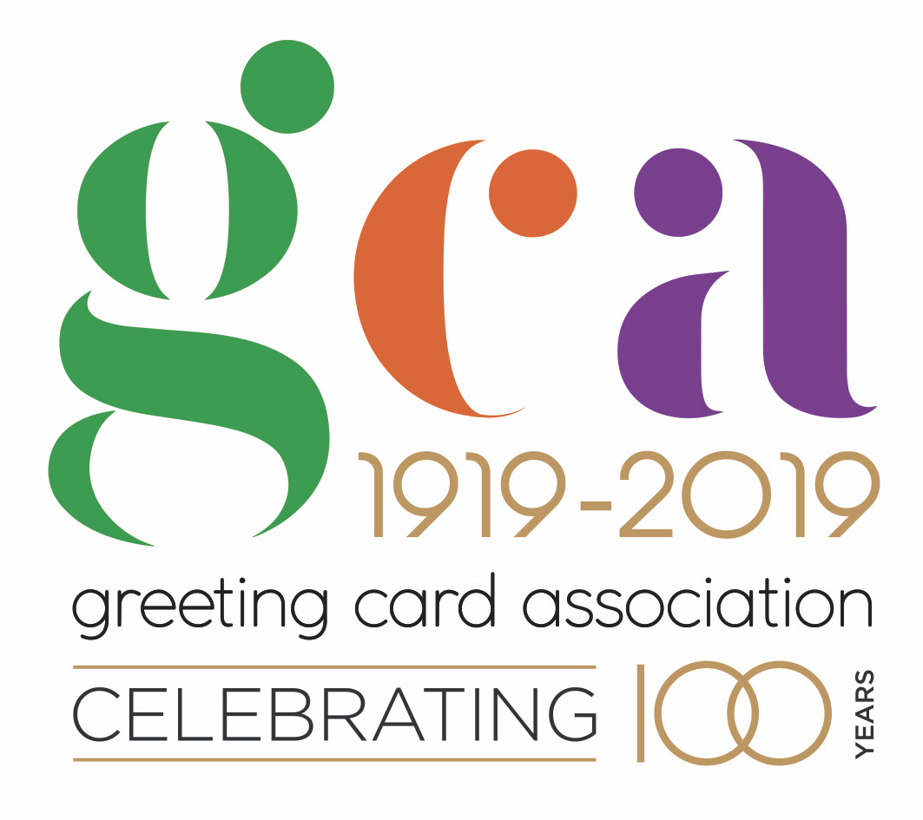

Isle of Man Post Office Celebrates the 100th Anniversary of the Greeting Card Association with this Year’s Christmas Stamps

Variety of Christmas Cards to be Featured on Christmas Stamps 2019

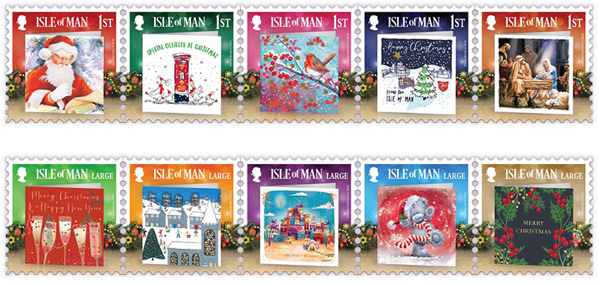

A selection of ten delightful greeting cards will be featured on the 2019 Isle of Man Christmas stamps celebrating 100 years of the Greeting Card Association.

The British are the most prolific card-sending nation in the world, spending £1.7 billion a year on greeting cards. The UK also leads the world in greeting card design and innovation which sees millions of UK cards exported all over the globe.

The first commercial Christmas card was sent in 1843, by Sir Henry Cole, the chief organizer of the Great Exhibition, pioneer of the penny post and founder of the V&A Museum. One of Sir Henry’s first Christmas cards, sent to his Grandmother, was recently sold at auction for $22,500

Christmas is a special as well as a sacred time for many, and the Christmas card is the perfect way of keeping in touch and letting family, friends and loved ones know that they are thought of. No other country has such a tradition of card sending or card display in the home - the sending and receiving of cards is an important part of our culture. After all you can’t put a text message on a mantelpiece!

Creative consultant Geoff Sanderson: “I was honoured to be asked to curate the cards used in this very special collection of stamps on behalf of the Greeting Card Association. The designs chosen evoke the spirit of the season, whilst featuring beautiful artwork from some of our leading artists and illustrators - showcasing the work of the publishers that the GCA supports.”
The Greeting Card Association on sending cards: “With scientific evidence proving that receiving greeting cards improves mental health and well-being, greeting cards continue to be the preferred choice to express sentiment to someone important. And with 18-24 year olds now sending more cards than a generation ago the great British tradition of card sending is set to continue.”

Maxine Cannon, General Manager, Isle of Man Stamps and Coins said: “We are pleased to present this joyful delivery of ten beautiful and diverse greeting cards as our festive stamp set for Christmas. The set celebrates the centenary of the Greeting Card Association and we are delighted to have been able to collaborate with the GCA and industry-leader Geoff Sanderson to mark the occasion and showcase the range of the membership’s work.”

The ‘Christmas Cards’ collection is available as Set and Sheet Set, Presentation Pack and First Day Cover. For further information, please see www.iompost.com/christmas-cards.

Further to the above mentioned products the stamps will also be available as variable value self-adhesive stamp collection (VVD). These will be vended via our retail kiosks, post office counter network and via hand-held vending machines at one-off events such as stamp exhibitions. Ramsey Philatelic Services is happy to provide a service to customers world wide.

TECHNICAL DETAILS
Design: EJC Design
Text & Concept: Geoff Sanderson
Printer: LM Group
Stamp Size: 32 x 32mm
Colours: 4 plus varnish
Process: Offset Lithography
Perforations: 14 per 2cms
Paper: 110 gms PVA Gummed
No. of Stamps: 10
Format: 2 Sheets of 25
Issue Date: 28th October 2019

NOTES TO EDITOR
- Photo embedded and attached of: Christmas Cards – The Spirit of Christmas Stamp Set
- Further attachments: Sheet Set, First Day Cover and Presentation Pack
- VVDs: Ramsey Philatelic Services is happy to provide a service whereby customers wishing to obtain examples of VVD’s from a kiosk location or counter position can place an order with them prior to the issue date of 28th October 2019. Contact Mike or Richard at boomland@manx.net Ramsey Philatelic Services, 5 Windsor Road, Ramsey, Isle of Man, IM8 3EG.
- Text attached: Issue Text with detailed information
- Creative Consultant Geoff Sanderson, who wrote the issue text for this stamp collection, trained as an illustrator to work in advertising. After he discovered that the 80s advertising world was not his cup of tea he decided to follow his true star and became a greeting card designer followed by a career as a creative director in the greeting card industry. Along the way he designed and managed ranges for may UK retailers including Marks & Spencer, the global greetings publisher Hallmark and most recently developed personalised cards for the print-on-demand etailer moonpig.com.
- The Greeting Card Association: Founded in 1919, the voice of the British greeting card industry, the GCA is an independent trade organisation, wholly owned by its members - greeting card publishers, retailers and manufacturers.
- The Isle of Man Post Office with their business division Integrated Mailing Solutions is the only mailing house directly integrated into the UK next day postal network.
- For further pictures please visit our Media Centre where you can freely download copy, latest news, copyright free and approved images http://www.iompost.com/media-centre/login/
Issued by Nicole Livingston, PR, Communication and Social Media Executive, Isle of Man Post Office
Tel: 01624 698471 Email: nicole.livingston@iompost.com

Sales & Marketing  Phone: +44 (0)1624 698 437  Email – Maxine Cannon  maxine.cannon@iompost.com  Office hours: Monday to Friday 8.30am to 5pm GMT |   Customer Services  Phone: +44 (0)1624 698 430  Fax: +44 (0)1624 698434  Email: stamps@iompost.com  www.iomstamps.com

