Date: 1st June 2019

ISLE OF MAN POST OFFICE AND TREASURY PRESENT STEVE HISLOP 120MPH ANNIVERSARY COIN TO THE HISLOP FAMILY

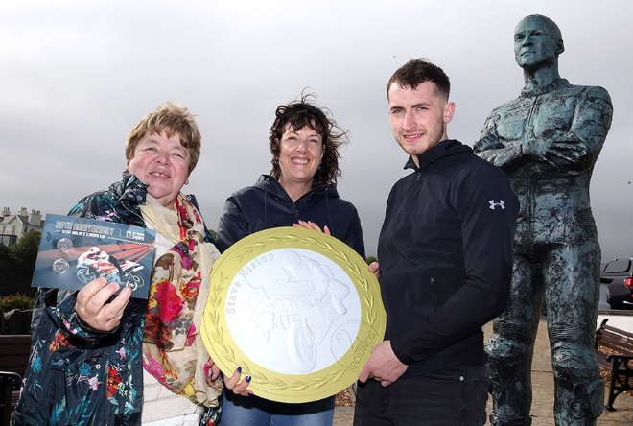

IOMPO Stamps & Coins, in conjunction with the Isle of Man Treasury and Tower Mint Ltd, were delighted to present the Hislop family, represented by Connor Hislop (son), with three special limited edition Coin & Stamp packs in celebration of the 30th anniversary of Hizzy’s record-breaking 120mph TT lap.

To honour Steve Hislop’s achievement 30 years ago, Connor Hislop, representative for the family, was presented with 3 very special numbered versions of the commemorative Coin & Stamp pack: Number 11 to mark his eleven TT wins, number 19 – the number he raced with in the legendary Senior TT race of 1992 to mark his victory and number 120 to mark the occasion he broke the 120mph barrier around the world-famous course.

Celebrating this momentous occasion at the Steve Hislop Memorial on Onchan Head with the family were Maxine Cannon (General Manager Stamps & Coins), Babs Cowley (Senior Accountant Isle of Man Treasury), Paul Quayle and Bill Snelling (FoTTofinders and author of the collection text).

The commemorative Coin & Stamp gift pack is limited to just 1000 units and features both £2.00 coins and a stamp with a special 30th anniversary postmark date June 3rd 2019. The Set of two brand new £2 Coins are available in a gift wallet and have generated a very keen interest already from TT fans around the world.

The enlarged replica boards of the two coins will be auctioned after this year’s TT Festival to raise funds for the T.T. Riders Association (TTRA).

Connor Hislop said: “I'm pleased to be presented with this stunning Coin & Stamp Gift Set from Isle of Man Post Office. They are a special way to celebrate my father’s career and achievements.”

Maxine Cannon, General Manager, Isle of Man Stamps & Coins, said: ‘Steve Hislop is a true TT legend and we are proud to be able to present the Hislop family here today and those currently off Island with these significant numbers of our limited edition Coin & Stamp Set.”

Steve Hislop’s 120mph Lap can be ordered from www.iompost.com/hislop.
ENDS
NOTES TO EDITOR
- Photo1 embedded and attached of Maxine Cannon (IOMPO), Babs Cowley and Connor Hislop
- Further attachments:
  - Photo 2: Connor Hislop,
  - Photo 3: Bill Snelling, Babs Cowley, Peter Farrer, Connor Hislop, Janet Quayle, Maxine Cannon, Paul Quayle
  - Photo 4: Peter Farrer (Grandfather of Connor) Kelly McCulloch (Mother of Connor) & Connor Hislop
- Donations will be made to the TT Riders Association.
- Stamp & Coin Pack: The issue features photographs from the archives of “FoTTofinders” with the story of Hislop’s early TT years written by Bill Snelling. It also recalls personal tales from Hislop’s F1 victory including the lap he found his front brake was defective and had to take a corner into Kirk Michael on the pavement! The stamp also featured in a four-stamp collection, TT Winners, which was issued by the Isle of Man Post Office in 2017.
- Set of two brand new £2 coins which have been issued by Isle of Man - presented in a wallet.
- Get the latest Isle of Man Stamps and Coins news at www.facbook.com/IsleofManStampsandCoins
- For further pictures please visit our Media Centre where you can freely download copy, latest news, copyright free and approved images http://www.iompost.com/media-centre/login/

Sales & Marketing  Phone: +44 (0)1624 698 437  Email – Maxine Cannon  maxine.cannon@iompost.com  Office hours: Monday to Friday 8.30am to 5pm GMT | Customer Services  Phone: +44 (0)1624 698 430  Fax: +44 (0)1624 698434  Email: stamps@iompost.com  www.iomstamps.com

