Date: 10th March 2020

Isle of Man Post Office Celebrates the Douglas School of Art

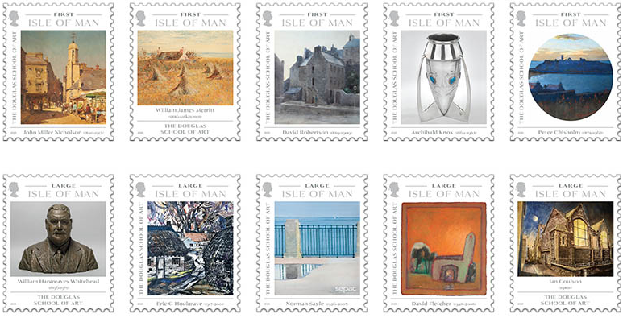

The Isle of Man Post Office presents a celebration in ten stamps of the principal artist-lecturers who inspired successive generations at The Douglas School of Art to be issued 16th of March 2020.

While this year marks the centenary of the school as a publically-funded educational establishment its history extends back into the nineteenth century. Graduates of the school have earned a reputation for high achievement in many areas of art and design worldwide and all recognise their debt to the inspirational individuals who fostered their creative beginnings.

The school has produced prominent names such as Archibald Knox, Norman Sayle and John Miller Nicholson; all of whom also worked as lecturers at the school. The stamps display the works of some of the Island’s most important artists and will provide information behind the artwork, its artist, and their relationship with the Douglas Art School.

Ian Coulson, Artist and former Douglas School of Art student, tutor and Foundation Course Leader 1987-2016, who also contributed to the issue text said: "I’m so excited to be involved in the design of my first stamp. As a teenage art student I was in awe of David Gentleman’s stamp designs for the UK Post Office. I’m really happy to be joining the several of my very talented students who have already seen their work published by the Isle of Man Post Office.”

Maxine Cannon, General Manager Isle of Man Stamps & Coins, said:” This beautiful and versatile collection is the product of a fruitful and successful collaboration between many involved and we are very grateful to be able to support Manx culture through the promotion of locals artwork and local artists.”

The ‘Douglas Art School’ collection is available as Set and Sheet Set, Sheetlet, Presentation Pack and as First Day Cover. As an additional product this collection is available as a self-adhesive booklet of 10 stamps. For further information, please see www.iompost.com/DouglasArt.

TECHNICAL DETAILS

Issue title: The Douglas School of Art
Text: Yvonne Cresswell, Ian Coulson
Design: EJC Design
Printer: Lowe Martin
Process: Offset Lithography
Colours: 4
Paper: 110 gms PVA gummed
Perforations: 13 per 2cms
Stamp Size: 40 x 32mm
No. of Stamps: 10
Format: Sheets of 20
Date of Issue: 16th March 2020

NOTES TO EDITOR
- Photo embedded of Stamp Set
- Further attachments: Stamp Set, First Day Cover, Presentation Pack & Sheet Set
- Acknowledgements :We are very grateful to the following for their kind assistance in the production of this issue: Manx National Heritage, Carola Rush, Rosemary Sayle, Eileen Schaer, Deborah Taubman, Gallery Oldham.
- Art, Design & Media at University College Isle of Man
Douglas School of Art (DSA) was established in the 1880s with a purpose: ‘to promote the growth of industrial art, to supply training for those adopting art as a profession and to foster public taste in arts and crafts’.
Over the years, the Art School flourished and evolved in to what is now University College Isle of Man (UCM), which these days offers a far more expansive range of courses which encompass and reach beyond the original creative arts focus. Incorporating and developing many other subject disciplines over its 140 years, UCM still maintains its founding ethos of nurturing future careers and supporting the local community, with a vision to ‘deliver learning that is world-changing and drives our nation’s future’.
The Art, Design & Media programme area at UCM has been carrying on the tradition of providing students with the opportunity to explore their interest in the creative arts. The Henry Loch Art Studios, named to honour Lieutenant Governor Henry Loch who was instrumental in the establishment of the DSA, has been recently refurbished, proving further the continued value placed on the creative arts at the University College.
Whilst the philosophy of the DSA is still relevant today, the range of creative courses on offer has grown to extend beyond the traditional art techniques of drawing, painting, printmaking and ceramics, to include visual communications, music and media in order to meet the demands of the digital age. To support this, the art studios have been designed to enable students to explore and experiment with diverse materials, processes and technologies.
All the tutors are practitioners in their specialist areas, and are therefore best placed to impart their knowledge and experience to students. Those who have studied here have progressed into exciting and meaningful careers across the globe, some have even come back as tutors themselves, thus carrying on the tradition of inspiring, challenging and empowering many more generations of creative practitioners in the creative industries and beyond.
- Original artwork copyrights (with permissions) Manx National Heritage unless stated.
- Every effort has been made to trace or contact all copyright holders. The Isle of Man Post Office will be pleased to make good any omissions or rectify any mistakes brought to their attention at the earliest opportunity.
- For further pictures please visit our Media Centre where you can freely download copy, latest news, copyright free and approved images http://www.iompost.com/media-centre/login/
- Please feel free to contact us if you require a PR sample of the stamps.

Issued by Nicole Livingston, PR, Communication and Social Media Executive, Isle of Man Post Office
Tel: 01624 698471 Email: nicole.livingston@iompost.com

Sales & Marketing  Phone: +44 (0)1624 698 437  Email – Maxine Cannon  maxine.cannon@iompost.com  Office hours: Monday to Friday 8.30am to 5pm GMT |   Customer Services  Phone: +44 (0)1624 698 430  Fax: +44 (0)1624 698434  Email: stamps@iompost.com  www.iomstamps.com

