Date: May 20th 2019

ISLE OF MAN POST OFFICE CELEBRATES EMINENT VICTORIAN ENGINEERS ON THE 200TH ANNIVERSARY OF THE BIRTH OF HM QUEEN VICTORIA

MANX ENGINEERING HONOURED ON STAMP COLLECTION

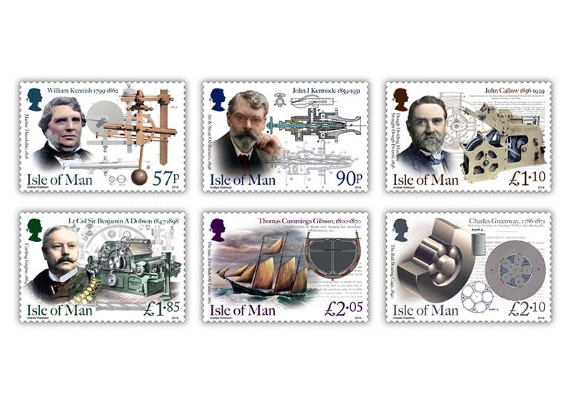
May 24th 2019 marks the 200th anniversary of the birth of HM Queen Victoria. The Isle of Man Post Office is delighted to celebrate the great works and inventions of six eminent Victorian engineers who have hugely influenced on the historical development of engineering, science and technology still used today in everyone’s daily lives.
This stamp issue presents six great engineers and inventors who influenced food manufacture, clothing, naval gunnery, modern machinery, oil shipments and engine fuel injection in original and unique ways now almost forgotten. It is a celebration of what the Isle of Man does well - providing opportunities to develop great people who go on to provide great service to mankind. Each of these great engineers was either born in the Isle of Man or created their ideas whilst living and working here.
William Kennish: Invented the "marine theodolite", which when combined with his gun breast-plate and quoin, allowed the fire of a warship to be concentrated to a point. The 'gun commander' operating this would line up the ship to the target, pull ropes ringing bells on each gun deck causing all the guns to be fired. It was the first example of a centralised gun command system, now fitted to every modern warship afloat today.
John Jonathan Kermode: Developed fuel injection nozzles which operated by steam or hot air pressure. This forced a spray of fuel oil droplets into the igniters of large marine steam boilers, allowing steam to be generated very quickly.
John Callow: Invented the 'straight dough' process which took hours off the rising time for dough used beforehand and then went on to develop dough cutting machinery which allowed bread production rates to soar. This had the benefit of reducing the cost of bread – a key staple food to the poor of Liverpool.
Benjamin Alfred Dobson: Developed and ran a very successful textile machinery business called Dobson and Barlow. His inventive improvements were very successful and his machinery was sent worldwide.
Thomas Cummings Gibson: Launched the fast wooden schooner called The Jane which had integral iron tanks with his special vapour seals and it became the first true oil tanker to service American oil fields in Pennsylvania! He also launched the two greatest ships ever to sail from the Isle of Man!
Charles Greenway: Patented the 'free floating' cage or as he called it the "cradle", for cylindrical, conical and spherical roller bearings. This differed from the original cage developed by the horologist John Harrison in his H3 Timepiece of the 1750s which relied on axles to keep the rollers separated.
Robert (Bob) Stimpson, Chairman of the Isle of Man Victorian Society and Fellow of the Institution of Mechanical Engineers said: “I was delighted to be invited to work with the Isle of Man Stamps & Coins team to advise on the selection of these six subjects and to provide the base images which have been transformed into this remarkable stamp issue. Each stamp tells the story of a modest man who has transformed their profession, resulting in tremendous subsequent developments based on their Manx experiences.”

Maxine Cannon, General Manager, Isle of Man Stamps and Coins said: “We are honoured to present these great Manx citizens, by birth or by choice, whose inventiveness influenced engineering, science and technology profoundly. Great achievements like these mean a lot to our community and we are proud that they form part of our heritage.”

The ‘Eminent Victorian Engineers’ collection is available as Set and Sheet Set, Presentation Pack and First Day Cover. For further information, please see www.iompost.com/engineers.

TECHNICAL DETAILS
Images: Andrew Robinson
Text: Robert Stimpson
Printer: Lowe Martin
Stamp Size: 42.58 x 28.45mm
Colours: 4
Process: Offset Lithography
Perforations: 14 per 2cms
Paper: 110 gms PVA Gummed
No. of Stamps: 6
Format: Sheets of 20
Issue Date: 24th May 2019

NOTES TO EDITOR
- Photo embedded and attached of Stamp Set
- Further attachments: Photo of Robert Stimpson with the stamps, Presentation Pack and First Day Cover
- Text attached: Issue Text with detailed information
- For further pictures please visit our Media Centre where you can freely download copy, latest news, copyright free and approved images http://www.iompost.com/media-centre/login/

Issued by Nicole Livingston, PR, Communication and Social Media Executive, Isle of Man Post Office
Tel: 01624 698471 Email: nicole.livingston@iompost.com

Sales & Marketing  Phone: +44 (0)1624 698 437  Email – Maxine Cannon  maxine.cannon@iompost.com  Office hours: Monday to Friday 8.30am to 5pm GMT |   Customer Services  Phone: +44 (0)1624 698 430  Fax: +44 (0)1624 698434  Email: stamps@iompost.com  www.iomstamps.com

