Date: 21st June 2019

ISLE OF MAN POST OFFICE CELEBRATES MANX GAELIC WITH A CHARMING STAMP COLLECTION “GREETINGS IN MANX” DESIGNED BY MARY COUSINS

Y GHAELG – CHENGEY NY MAYREY VANNIN
MANX – THE MOTHER TONGUE OF THE ISLE OF MAN

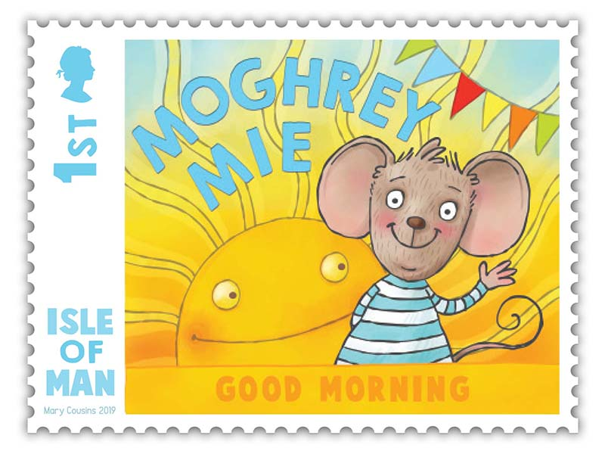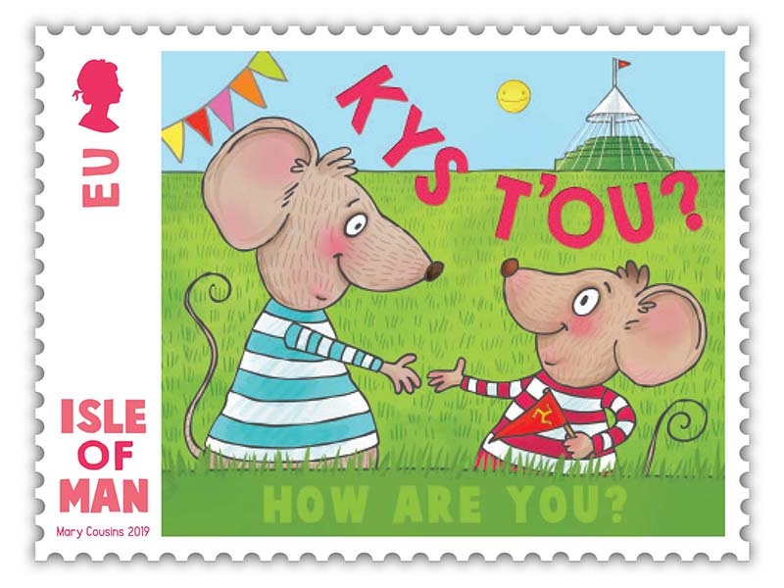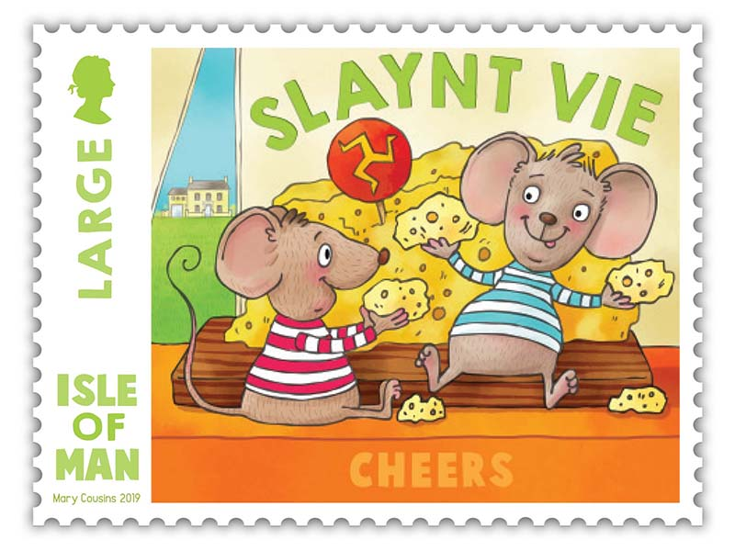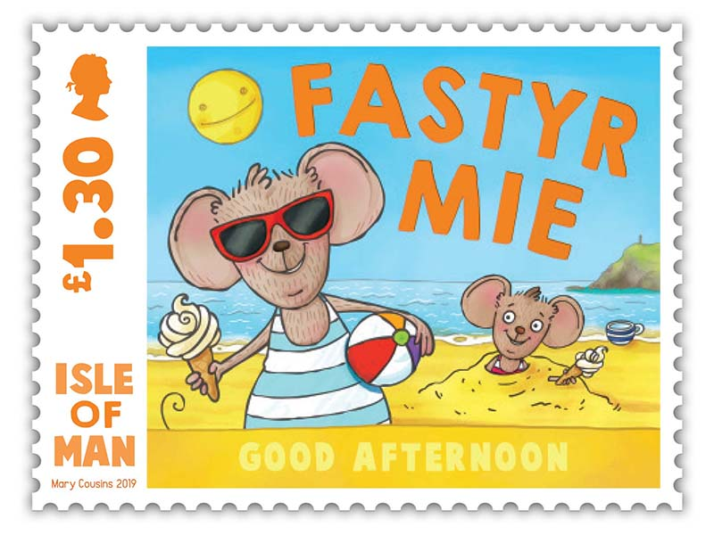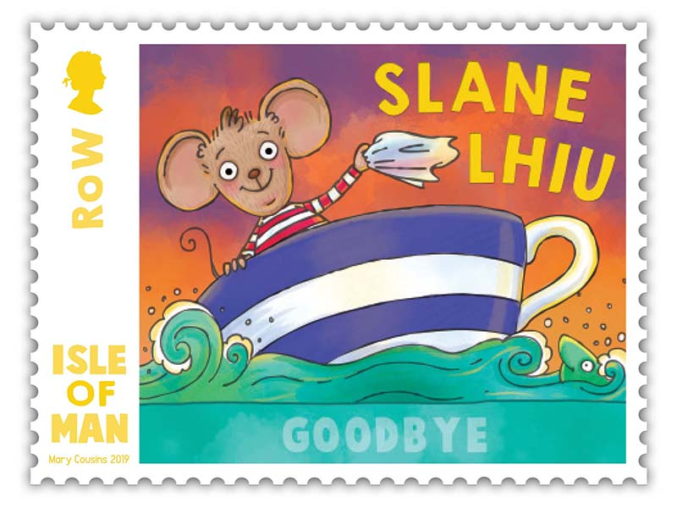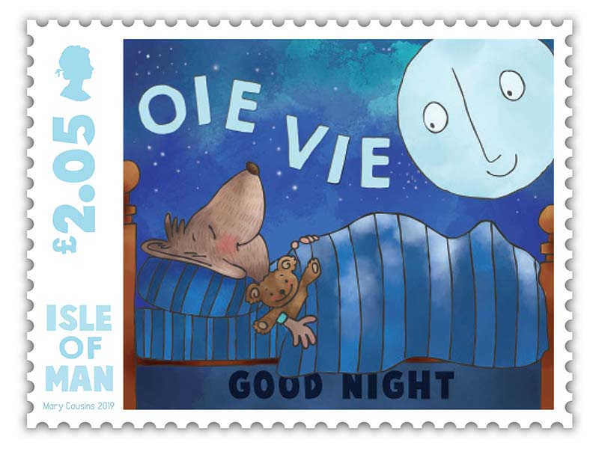

The Isle of Man Post Office (Oik Postagh Ellan Vannin) is pleased to encourage popular use of the Manx language by presenting this joyful set of six stamps (issue date 4th July 2019) which is a collaboration between Culture Vannin and Manx artist Mary Cousins. The issue coincides with the 120th anniversary of the Manx Language Society and the International Year of Indigenous Languages 2019, of which Culture Vannin is a partner organisation.

Beautifully illustrated by Manx artist Mary Cousins, these stamps perfectly demonstrate the success story of Manx Gaelic. Driven by the Manx Language Society a language, that was nearly lost, has been painstakingly revived. As a result of well organised community based initiatives over

the last century and a half, coupled with targeted Isle of Man Government support, the language has seen an upsurge of interest in recent years and is now available for all ages to enjoy, within nurseries, schools, adult classes and the wider community.

There are now well over a thousand children learning Manx across all schools and with more adults learning Manx too, its impact on worldwide efforts to protect and promote endangered languages is huge. The Isle of Man is now looked to by many as an example of best practice.

The artist, Mary Cousins, says: “It has been a real pleasure to work with Culture Vannin and the Isle of Man Post Office on this issue and a privilege to see my characters on stamps. It’s exciting to think of them travelling around the world through the mail and I hope they spread a little Manx cheer on the way.”
The collection consists of a set of six stamps, a First Day Cover and a Presentation Pack:
Maxine Cannon, General Manager, Isle of Man Stamps and Coins said: “We are incredibly proud of our Manx heritage, including our wonderful language Manx Gaelic. When we embarked on this project raising awareness for our language was the key objective and we are grateful to have Culture Vannin, Jamys O’Meara and the talented Mary Cousins by our side to support our efforts."

“Tinvaal Aboo”: To encourage even more people to learn and speak Manx, IOMPO will be using a special designed postmark “Tinvaal Aboo”, meaning “Hurray For Tynwald” during Tynwald week. On Tynwald Day IOMPO and Culture Vannin will be giving away stickers along with a themed Manx language pocket guide to ‘Greetings in Manx’ and postcards featuring the designs of the stamp collection. So come and visit Culture Vannin!

The ‘Greetings in Manx’ collection is available as Set and Sheet Set, Presentation Pack and First Day Cover. For further information, please see www.iompost.com/greetings.

TECHNICAL DETAILS
Illustrations: Mary Cousins
Text: Jamys O’Meara/Culture Vannin
Design: EJC Design
Printer: Lowe Martin
Process: Offset Lithography
Colours: 4
Paper: 110 gms PVA gummed
Perforations: 13 per 2cm
Stamp Size: 40 x 30mm
Format: Sheets of 20
Date of Issue: 4th July 2019

NOTES TO EDITOR
- Photo embedded and attached of Stamp Set
- Further attachments: Sheet Set, First Day Cover and Presentation Pack
- Text attached: Issue Text with detailed information
- About the artist Mary Cousins: Mary Cousins is a Manx-born published illustrator and award-winning artist. She studied at the IOM College and Kingston School of Art in London and counts drawing and needle-felting as her favourite activities. Mary was recently commissioned by Culture Vannin to produce a series of advent calendar illustrations. Her work can be viewed at instagram.com/maryfcousins.
- About the Issue Text Author Jamys O’Meara (Culture Vannin): Jamys is the current Manx Language Development Officer (Yn Greinneyder) for Culture Vannin. The role is to raise the profile of Manx Gaelic both within the Island and internationally and to assist organisations who work to support the language. The adult language programme now includes online lessons and resources to complement the established publishing catalogue, as well as Culture Vannin’s two highly-praised Manx language apps. Jamys will continue this important work and focus on creating resources suitable for learners at intermediate and higher levels. Yn Greinneyder works to deliver the Manx Language Strategy developed by Culture Vannin in collaboration with the Department of Education, Bunscoill Ghaelgagh and Mooinjer Veggey, together with the Manx-speaking community. www.culturevannin.im.
- The International Year of Indigenous Languages 2019: In 2016, the United Nations General Assembly proclaimed 2019 as the International Year of Indigenous Languages and requested the United Nations Educational, Scientific and Cultural Organisation (UNESCO) to serve as the lead organisation. An International Year is an important cooperation mechanism dedicated to raising awareness of a particular topic or theme of global interest and helping to foster and promote unique local cultures, customs and values which have endured for thousands of years. Indigenous languages add to the rich tapestry of global cultural diversity. Without them, the world would be a poorer place. Celebrating IYIL2019 will help promote and protect indigenous languages and improve the lives of those who speak them and will contribute to achieving the objectives set out in the United Nations Declaration on the Rights of Indigenous Peoples and the 2030 Agenda on Sustainable Development. https://en.iyil2019.org
- For further pictures please visit our Media Centre where you can freely download copy, latest news, copyright free and approved images http://www.iompost.com/media-centre/login/

Issued by Nicole Livingston, PR, Communication and Social Media Executive, Isle of Man Post Office
Email: nicole.livingston@iompost.com Tel: 01624 698471

Sales & Marketing  Phone: +44 (0)1624 698 437  Email – Maxine Cannon  maxine.cannon@iompost.com  Office hours: Monday to Friday 8.30am to 5pm GMT |   Customer Services  Phone: +44 (0)1624 698 430  Fax: +44 (0)1624 698434  Email: stamps@iompost.com  www.iomstamps.com

