Date: 23rd September 2019

Coin Flip – A Chance to Own Two Steve Hislop Memorial Coin Boards Signed by Motorbike Racing Royalty

The Isle of Man Post Office Will be Auctioning Two Steve Hislop Memorial Coin Boards to Raise Funds for The TT Riders Association

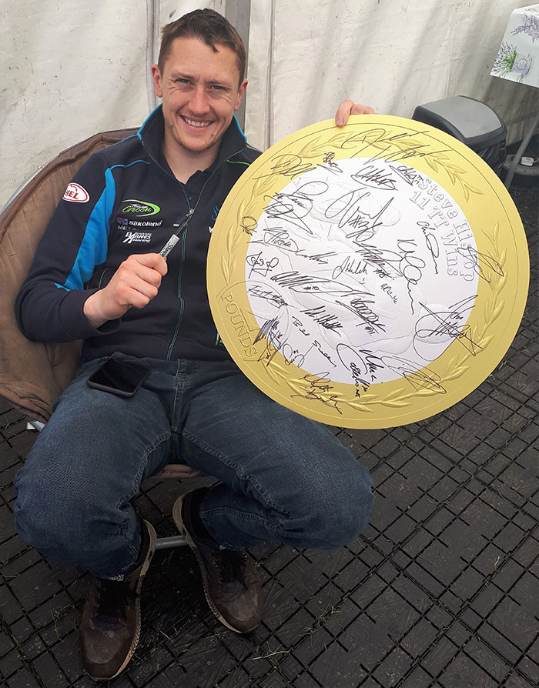

In conjunction with this year’s Isle of Man Classic TT we celebrate the life and career of Steve Hislop, one of the greatest British motorcycle racers of all time. Entitled ‘Back to the Future: The Hizzy Years’ this celebration took place 30 years after Steve set the first ever 120mph lap around the legendary TT Mountain Course, a speed that remains a benchmark three decades on.
A set of two signed presentation boards by TT riders and VIP's will be up for auction. Each of the two coins measures 50cm diameter and have been hand-signed during either the 2019 TT or 2019 Festival of Motorcycling. A list of signatures can be found below. The coins will come complete with a disc of images of the TT riders and VIP's holding the coin they have autographed. Proceeds of the auction will be donated to the TT Riders Association.

Isle of Man Stamps & Coins General Manager, Maxine Cannon said, “We are immensely proud to partner with the T.T.R.A. to not only raise funds for the charity but also to commemorate one of the greatest TT Riders who set the first ever 120 mph lap on the mountain course. In 2011, the Centenary of the TT Mountain Course, fans chose the 1992 Senior TT, (which quickly unfolded into a thrilling battle between Steve Hislop and Carl Fogarty), as the greatest race of all time on the iconic Mountain Course.” She added “We must remember too that without the enthusiasm and support of Paul and Janet Quayle who carried the boards around the Grandstand , Peel Day on Mad Sunday and Festival of Jurby, none of this would be possible. When we offered up the TT Legends replica 50p coins they raised £1001 let’s see if we can break the record this time around.”

Full list of names who have hand-signed each of the two presentation boards;
Coin 1:
RIDERS PAST & PRESENT
Michael Dunlop, Guy Martin, John McGuinness, Bruce Anstey, Dean Harrison, Connor Cummins, Ian Hutchinson, Peter Hickman, Michael Rutter, Ian Lougher, James Hillier, Gary Johnson, David Johnson, Jamie Coward, Cameron Donald, Steve Plater, Phillip McCallen, Ben Birchall, Tom Birchall, Dave Molyneux, Harry Payne, Maria Costello, Julie Canipa, Conrad Harrison, Andy Winkle, John Holden, Tom Weedon, James Hind, Nick Jefferies, Ryan Farquhar, Richard “Milky” Quayle, Sammy Miller, Billy McCosh, Doug Lunn, Timothee Monot,
Coin 2
RIDERS PAST & PRESENT
Carl Fogarty, Giacomo Agostini, Mick Grant, Charlie Williams, Brian Reid, Alex George, Trevor Nation, Horst Saiger, Steve Parrish, Bill Swallow, John Barton, Gary Dunlop, Ben Binns, Patrick Farrance, Dan Cooper, Richard Kneen, Dave Roper, Danny Webb, Paul "Moz" Owen, Dave Madsen-Mygdal, Davey Todd, Nathan Harrison, Graham English, Andy Farrell, John McBride, Kevin "Ago" Murphy, Malcom Wheeler, Veronika Hankocyova, Michal "Indi" Dokoupil, Bill Ingham, Tom Dickie, Neil Tuxworth, David Cretney, Kenny Arthur
FROM THE COIN LAUNCH NIGHT: Margaret Hislop (Hizzy’s mother), Aaron Hislop (Hizzy’s son), Connor Hislop (Hizzy’s son), Kelly McCulloch, Stephen Davison, Bill Snelling, Stephen Watson (BBC Northern Ireland Reporter), Matt Roberts (ITV4 Presenter), Wilson Craig (Team boss), Clive Padgett (Team boss), Rachael Clegg (Calendar girl & journalist), Roy Moore (Isle of Man Radio TT), Phil Taubman (Pit lane / return road), Alex Downie (Pit lane / return road), Neil Hanson (ex Clerk of the Course), Adrian Earnshaw (Hailwood Centre), Gary Roberts (Chief Constable), Martin Brunnschweiler (owner of Bushy’s Brewery), Paul Phillips (DFE Motorsports team), Wheelie Konni Ammenhauser (the man with all the badges), Gary Thompson (Clerk of the Course), Derry Kissack (the voice of the Purple Helmets), Lloyd Mister (the man in charge of the trophies), Dave Dentith (Chief Marshal)
TTRA members:
Frances Thorp (secretary), Paul Quayle (FoTTRA), Mick Chatterton (ex rider), Vin Duckett (ex rider),

OTHERS:
Paul Kermode (Start line controller – the man who sets them off & flags them home), Peter Maddocks (MMCC Chairman), Peter Duke (son of Geoff Duke, head of Duke Video), Colin Whittamore (heads up the Mugen team), Chris Beauman (he promotes sidecar racing & made the “3 Wheeling” movie), The Isle of Man TT Radio team: Chris Kinley, Chris Palmer, Chris Boyd, Alex Brindley, Tim Glover

You can find further details including all of the images captured of the riders and VIP's on our Facebook page http://bit.ly/hislopcoinalbum

The online auction (e-bay) of the coin boards will commence at 12.00 pm GMT, Monday 23rd September 2019, and will end at 12.00pm GMT on Thursday 3rd October 2019.

http://bit.ly/auctionHislopCoin

The auction will be held on e-bay. For more information please visit http://www.iompost.com/our-news/. To find out more about the coin collection, please visit www.iompost.com/hislop.

-ENDS-

NOTES TO EDITOR
- Photo embedded and attached of: TT 2019 Winner Dean Harrison.
- The T.T. Riders Association (TTRA) is an Isle of Man registered charity for motorcycle racers. It’s only when things go wrong, when help is really needed, that the TTRA enters the consciousness of a past or current TT rider or their family and friends. The mix of manufacturer-supported stars, on works machines, and penniless privateers on home prepared bikes which you can see at today’s TT is not new in road racing. It was this unequal struggle that provided the original inspiration for the TTRA. Back in the 1940s and 50s factory supported stars had contract clauses which included accident insurance, and even funeral expenses. The rest of the pack spent a year’s salary just to compete in the world’s greatest road race and they had nothing left for such cover. Consequently when things went wrong events invariably brought about untold hardship for the riders’ unfortunate families. During the 1949 races a rider crashed and was killed. Having no financial means to return his body home he was buried in a pauper’s grave, with just a pair of handlebars as a headstone. TT start-line marshal Rueben Harveyson was so incensed that he called a riders’ meeting in Belfast later in the year, and as a result the embryo of the TTRA was formed. Support from the top riders was instant and by 1951 the association was born and the charity was up and running. For more information visit www.ttra.co.uk
- For further pictures please visit our Media Centre where you can freely download copy, latest news, copyright free and approved images http://www.iompost.com/media-centre/login/

Issued by Nicole Livingston, PR, Communication and Social Media Executive, Isle of Man Post Office
Tel: 01624 698471 Email: nicole.livingston@iompost.com

Sales & Marketing  Phone: +44 (0)1624 698 437  Email – Maxine Cannon  maxine.cannon@iompost.com  Office hours: Monday to Friday 8.30am to 5pm GMT |   Customer Services  Phone: +44 (0)1624 698 430  Fax: +44 (0)1624 698434  Email: stamps@iompost.com  www.iomstamps.com

