Date: May 2019

ISLE OF MAN POST OFFICE CONTINUES STAMP COLLECTION FEATURING PAINTINGS OF THE LATE JOHN HALSALL

MANX MARITIME HISTORY REFLECTED ON STAMP COLLECTION

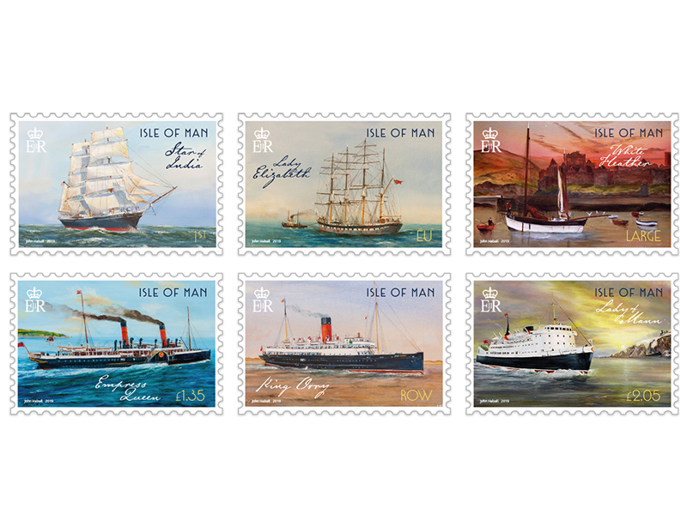
On May 18th 2019 Isle of Man Post Office will issue a set of six stamps featuring the paintings of Manx artist and mariner, the late John Halsall along with commentary by Matthew Richardson, Manx National Heritage Curator of Social History.

Surrounded by the Irish Sea the Isle of Man is proud of its maritime history Manx vessels of all sizes have played an enormous role in its history, and are fondly and proudly remembered by its people. Many thousands of Manxmen (and women) have made their living from the sea, in various capacities, as boatbuilders, fishermen, merchant sailors, or stewardesses.

This beautiful stamp collection is based on paintings of Manx born John Halstsall who was born during World War II in Douglas but raised in Laxey. The sea and ships captivated him from his earliest days and all his life John worked on the high seas. First and last with the Isle of Man Steam Packet but with nearly 30 years in between as local fisherman and ‘deep sea’ merchant seaman. John continued to paint his favourite

subjects in oil and watercolour right up to his death in 2017: Manx vessels of every variety, harbour views, and, occasionally, the Laxey Wheel. John worked with integrity, conviction and humility and brought his love of the wide open seas indoors, captured in paint.

The following ships are beautifully illustrated by John Halsall on this set of six stamps.

The Star of India (1863) was constructed as the Euterpe, by the Ramsey ship yard . She is the oldest iron-hulled merchant ship still floating.

The Lady Elizabeth (1879) was not Manx built but was commanded by George Christian Karran of the Karran Fleet, sailing out of Castletown.

The Nobby White Heather (1904) was built by Neakle & Watterson of Peel, and was registered as a fishing boat with port code PL5.

Empress Queen (1897) was the most powerful paddle steamer ever constructed, and during the First World War she became a troopship. She was lost when she ran aground on the Isle of Wight.

SS King Orry (1913) was built by Cammell-Laird at Birkenhead. She became an armed boarding vessel in the North Sea, searching for contraband and enforcing the blockade against Germany until returning to passenger duties between the wars. She was lost to enemy action whilst taking part in the Dunkirk evacuation of 1940.

Lady of Mann was constructed by Ailsa Shipbuilding at Troon. After decommissioning in 2005 the Lady of Mann ended her days as a passenger ferry in the Aegean, before being broken up in Turkey in 2011.

Matthew Richardson, Manx National Heritage Curator of Social History, who wrote the issue text for our collection, said: “I am delighted and honoured once again to be asked to contribute to a stamp issue featuring the work of the late John Halsall. His work does so much to capture the rich maritime heritage of the Isle of Man, and brings to life the many significant vessels which have sailed from its harbours.”

Maxine Cannon, General Manager, Isle of Man Stamps and Coins said: “We are honoured to be able to continue our series of maritime history with the impressive and beautiful paintings of John Halsall. We are very grateful to his family for permission to use his work once more for this collection.”

Acknowledgements
Our issue would not have been possible without the gracious assistance of the Halsall family who, in memory of John and their mother Sheila, will be making donations to IOM Hospice and the RNLI; charities with which both had close associations that have benefitted from John’s work in the past.

The ‘Maritime History II’ collection is available as Set and Sheet Set, Presentation Pack and First Day Cover. For further information, please see www.iompost.com/maritime.

TECHNICAL DETAILS

Images: John Halsall
Text: Matthew Richardson
Printer: Lowe Martin
Stamp Size: 42.58 x 28.45mm
Colours: 4
Process: Offset Lithography
Perforations: 14 per 2cms
Paper: 110 gms PVA Gummed
No. of Stamps: 6
Format: Sheets of 20
Issue Date: 18th May 2019

NOTES TO EDITOR
- Photo embedded and attached of Stamp Set
- Further attachments: Issue Text, Presentation Pack and First Day Cover
- For further pictures please visit our Media Centre where you can freely download copy, latest news, copyright free and approved images http://www.iompost.com/media-centre/login/

Issued by Nicole Livingston, PR, Communication and Social Media Executive, Isle of Man Post Office
Tel: 01624 698471 Email: nicole.livingston@iompost.com

Sales & Marketing  Phone: +44 (0)1624 698 437  Email – Maxine Cannon  maxine.cannon@iompost.com  Office hours: Monday to Friday 8.30am to 5pm GMT |   Customer Services  Phone: +44 (0)1624 698 430  Fax: +44 (0)1624 698434  Email: stamps@iompost.com  www.iomstamps.com

