Date: April 2019

ISLE OF MAN POST OFFICE PAYS TRIBUTE TO THE APOLLO MISSIONS AND THE 50TH ANNIVERSARY OF THE FIRST MANNED FLIGHT TO LAND ON THE MOON

THE ISLE OF MAN POST OFFICE PRESENTS LANDMARK ISSUE TO COMMEMORATE THE APOLLO PROGRAM

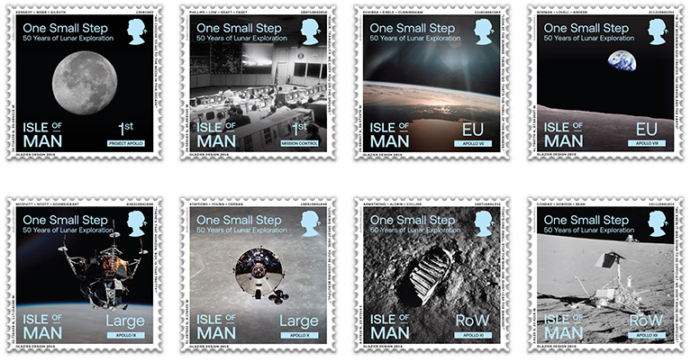

On April 29th Isle of Man Post Office issues a set of eight stamps to commemorate the semi centennial of the first manned flight to land on the Moon.

On May 5, 1961, four months after John F. Kennedy became president, Alan Shephard became the first American in space, however this was three weeks after cosmonaut Yuri Gagarin became the first human to orbit the Earth. Kennedy needed to be bold and in a speech to Congress stated “I believe that this nation should commit itself to achieving the goal, before this decade is out, of landing a man on the Moon and returning him safely to Earth.” The Apollo Program was born and the “Great Adventure” began.

Isle of Man Post Office proudly presents an impressive set of eight stamps covering the Apollo Missions with spectacular NASA photographs of the Moon itself as well as all the missions that led up to that ‘One Small Step’. The stamps show the beauty of space, the Moon and the vehicles that took humanity to the Moon. Through subtle references and codes on the stamps (and within NASA guidelines), the incredible NASA staff in Mission Control, the astronauts, the programs directors and those who gave their lives are included in this stunning testimony of the lunar exploration.

George Abbey, who worked with NASA during the Apollo missions and was director of the Johnson Space Center during the NASA Shuttle – Mir Program, said:” The stamps are truly outstanding and I am sure they will be well received”

Former NASA Astronaut Nicole Stott, wife of Manxman Chris Stott who spent a total of over 100 days in space during her two missions, said: “50 years ago this July two people stepped out onto the Moon, humanity’s first footsteps on another planetary body watched by the then largest television audience in history. Humanity came together crossing all boundaries for a few fleeting moments. The actions of these two men were supported by thousands more men and women on the ground. Many missions came before and came after Apollo 11. Now 50 years on we are only just now beginning to take those very same steps again, but this time we stay for good and like before for the good of all.”

Maxine Cannon, Isle of Man Stamps & Coins General Manager said: “The Moon landing and the Apollo program were milestones in the history of space travel and therefore deserve to be commemorated. We are very proud to honour the anniversary of the Moon landing with these impressive pictures captured on our stamps and are grateful to NASA and George Abbey in particular, for their support and assistance in bringing this collection to life.”

The ‘One Small Step’ collection is available as Set and Sheet Set, A5 Sheetlet, Presentation Pack, First Day Cover and a Prestige Booklet. For further information, please see www.iompost.com/moonlanding.

TECHNICAL DETAILS

Text: Mr George Abbey, Benedict Glazier
Design: Glazier Design
Printer: Lowe Martin
Process: Offset Lithography
Colours: 4 colour plus varnish
Paper: 110 gms PVA gummed
Perforations: 14 per 2cms
Stamp Size: 40 x 40mm
No. of Stamps: 8
Format: 24 stamps per sheet (12 x 2 designs)
Date of Issue: 29.04.2019

NOTES TO EDITOR
- Photo embedded of Stamp Set
- Further attachments: Commemorative Sheetlet and Prestige Booklet
- Photo of the stamp in Mission Control
- Photo of Nicole Stott, former NASA Astronaut, mission specialist and flight engineer
- Photo of George Abbey and Dr. Bonnie Dunbar
- Background Notes on Mr George Abbey:
Collated from Wikipedia. Mr Abbey was a US Air Force pilot before he joined NASA in 1964 as an Air Force captain assigned to the Apollo program. In December 1967 he left the Air Force and was named Technical Assistant to the Johnson Space Center Director. In January 1976, he was named Director of Flight Operations. In 1983 he became Director of the Flight Crew Operations Directorate; he was responsible for all space shuttle flight crews and put America’s first woman in space when he assigned Sally Ride to the crew of 1983′s STS-7. In July 1990, he was selected as Deputy for Operations and senior NASA representative to the Synthesis Group, charged with defining strategies for returning to the Moon and landing on Mars. In July 1991, Abbey was appointed Senior Director for Civil Space Policy for the National Space Council in the Executive Office of President George H. W. Bush. In 1994 Abbey was named Deputy Director of the Johnson Space Center and was subsequently selected as the JSC Director in 1996. As director of Johnson Space Center until 2001, he served as an integral part of the NASA Shuttle-Mir Program and provided crucial oversight, management, and guidance in the first phase of the International Space Station.”
- For further pictures please visit our Media Centre where you can freely download copy, latest news, copyright free and approved images http://www.iompost.com/media-centre/login/
- Please feel free to contact us if you require a PR sample of the stamps.

Issued by Nicole Livingston, PR, Communication and Social Media Executive, Isle of Man Post Office
Tel: 01624 698471 Email: nicole.livingston@iompost.com

Sales & Marketing  Phone: +44 (0)1624 698 437  Email – Maxine Cannon  maxine.cannon@iompost.com  Office hours: Monday to Friday 8.30am to 5pm GMT |   Customer Services  Phone: +44 (0)1624 698 430  Fax: +44 (0)1624 698434  Email: stamps@iompost.com  www.iomstamps.com

