Date: 12th June 2019

ISLE OF MAN STAMPS & COINS PRESENTS THE WORLD’S FIRST PETER PAN CIRCULATING COIN COLLECTION

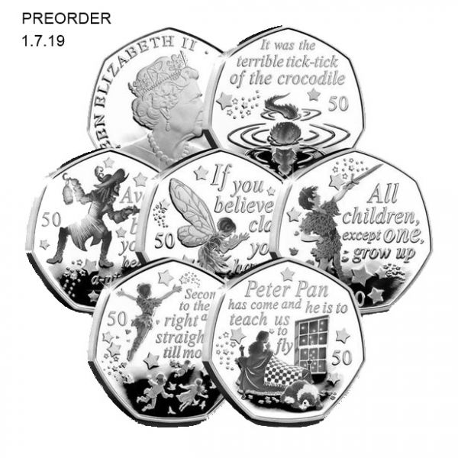

Isle of Man Post Office, a statutory board of the Isle of Man Government are pleased to present the world’s first Peter Pan circulating coin collection. Our set consists of six coins contained within packaging authenticating the collection. Each collection is packaged carefully and inspected prior to despatch.
Coin 1 – “All children except one” - Coin features a silhouette of Peter Pan, surrounded by stars and the inscription “All children, except one, grow up”
Coin 2 – “Avast belay, yo ho” – Coin features a silhouette of Captain Hook, surrounded by stars and the inscription “Avast belay, yo ho, heave to, a-pirating we go”

Coin 3 – “If you believe, clap your hands” – Coin features a silhouette of Tinkerbell, surrounded by stars and the inscription “If you believe, clap your hands”

Coin 4 – “It was the terrible tick-tick”- Coin features a silhouette of the crocodile in water, surrounded by stars and the inscription “It was the terrible tick-tick of the crocodile”

Coin 5 – “Peter Pan has come” - Coin features a silhouette of Wendy Darling sitting in bed, looking out through the window with the family dog beside the bed. The silhouette is surrounded by stars and the inscription “Peter Pan has come and he is to teach us to fly”
Coin 6 – “Second to the right” – Coin features a silhouette of Peter Pan and the Darling family flying to Neverland, surrounded by stars and the inscription “Second to the right and then straight on till morning”

Peter Pan 50p Six Coin Set can be pre-ordered from www.iompost.com/peter-pan.
ENDS
NOTES TO EDITOR
- Photo embedded and attached of six Peter Pan 50p Coins & obverse
- Get the latest Isle of Man Stamps and Coins news at www.facbook.com/IsleofManStampsandCoins
- For further pictures please visit our Media Centre where you can freely download copy, latest news, copyright free and approved images http://www.iompost.com/media-centre/login/

Sales & Marketing  Phone: +44 (0)1624 698 437  Email – Maxine Cannon  maxine.cannon@iompost.com  Office hours: Monday to Friday 8.30am to 5pm GMT | Customer Services  Phone: +44 (0)1624 698 430  Fax: +44 (0)1624 698434  Email: stamps@iompost.com  www.iomstamps.com

