Date: 24th July 2020

Free-to-Enter Photo Competition Captures Isle of Man’s Unique Beauty and Results in ‘O Land of Our Birth’ Stamp Issue

Public’s Photography Skills to Reflect Manx National Anthem in Stamp Issue

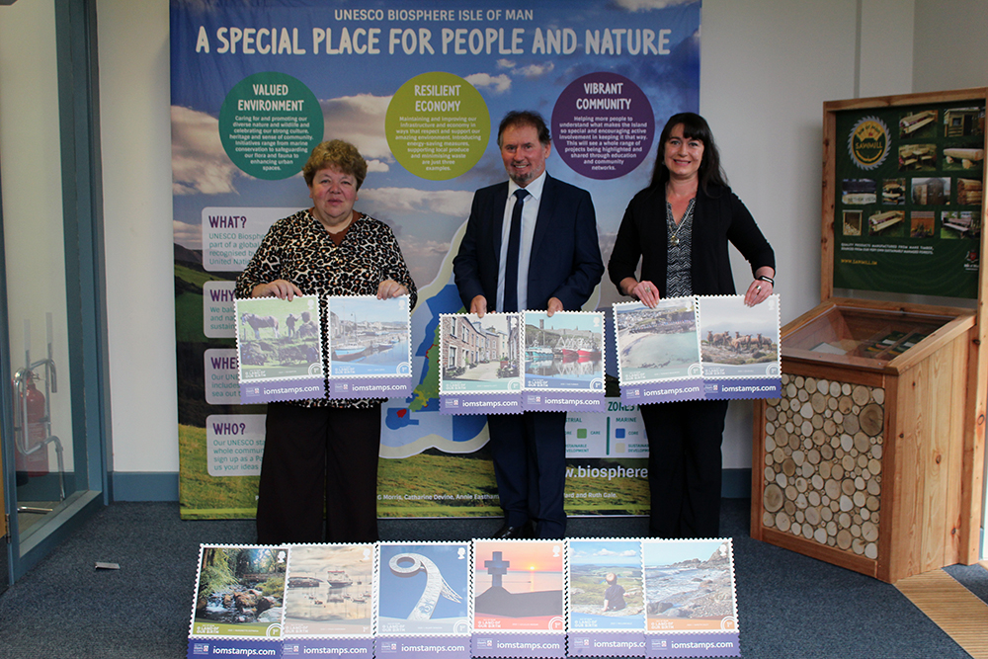

Isle of Man Post Office, in collaboration with the Isle of Man Steam Packet Company and UNESCO Biosphere Isle of Man, is pleased to announce a new stamp issue to be launched 29th July 2020.

These twelve stamps titled ‘O Land of Our Birth’ depict scenic images that are the result of an open, free-to-enter photo competition that was held in June this year. The public on the Island and in the UK was invited to submit their own photographs which they felt summed up the Island’s unique beauty, heritage and character, drawing inspiration from the words of the Manx National Anthem.

Over one thousand entries from IOM and UK individuals were entered into the competition and a final selection was made by judges Maxine Cannon (Stamps & Coins General Manager), Jo Overty (Project Officer UNESCO Biosphere Isle of Man) and Renee Caley (Marketing & Online Manager of Isle of Man Steam Packet Company).

Representing the general public’s view of the Island, the set reflects what the Isle of Man means to both residents and visitors alike. The stamps illustrate the natural beauty of our Island, showcasing striking landscape imagery from a variety of locations. This varied landscape is evoked in the lyrics of ‘O Land of Our Birth’, the Manx national anthem, which provides the title of the issue and accompanies each of the stamp images.

Geoffrey Boot MHK, Minister Department of Environment, Food and Agriculture & UNESCO Biosphere Isle of Man, said: “I am pleased to see the results of this collaboration. The stamps exemplify the beauty and heritage of Biosphere Isle of Man and demonstrate the skills in our community. Well done to the photographers featured.”

Renee Caley, Isle of Man Steam Packet Company, said: “The wonderful variety of photos submitted showcases the spectacular beauty of the Island and brings its unique personality and quirky character to life.”

Maxine Cannon, Isle of Man Stamps & Coins, said: “We take pride in this beautiful Island we live on. The diversity it has to offer in landscape, culture and heritage makes it unique and we are grateful for the contribution of everyone involved from near and far in capturing the beauty that surrounds us to create this stunning stamp issue. We would like to thank the Isle of Man Steam Packet Company and UNESCO Biosphere Isle of Man for joining us on this wonderful journey.”

The ‘O Land of Our Birth’ collection includes a set of twelve stamps, Presentation Pack, First Day Cover and Sheet Set and can be ordered from www.iompost.com/land.

-ENDS-

Technical Specifications
Issue title: ‘O Land of Our Birth’
Design: Isle of Man Advertising
Text: Maxine Cannon, Renee Caley, Jo Overty
Printer: Lowe Martin
Process: Offset Lithography
Colours: 4
Paper: 110 gms PVA gummed
Perforations: 13 per 2cms
Stamp Size: 32mmx 32mm
No. of Stamps: 12
Format: Sheets of 48
Date of Issue: 29th July, 2020

NOTES TO EDITOR
- For images of the stamps, please visit this link.
- Attachment 1: Issue Text
- Attachment 2: Manx National Anthem ‘O Land of Our Birth’
- Attachment 3: Photograph Maxine Cannon, Minister Geoffrey Boot & Renee Caley
- Get the latest Isle of Man Stamps and Coins news at www.facbook.com/IsleofManStampsandCoins
- Keep up-to-date with the latest news on Twitter: @IOMstampscoins
- Isle of Man Stamps and Coins is proud to be accredited and partnered with various organisations. For more information please visit here.

Issued by Nicole Livingston, PR, Communication and Social Media Executive, Isle of Man Post Office
Tel: 01624 698471 Email: nicole.livingston@iompost.com

Sales & Marketing  Phone: +44 (0)1624 698 437  Email – Maxine Cannon  maxine.cannon@iompost.com  Office hours: Monday to Friday 8.30am to 5pm GMT | Customer Services  Phone: +44 (0)1624 698 430  Fax: +44 (0)1624 698434  Email: stamps@iompost.com  www.iomstamps.com

