Date: 30th December 2020

Popular and Unusual Species of Birds to be Showcased by Isle of Man Post Office

Seen Through the Lens of Photographer Luke Stephenson

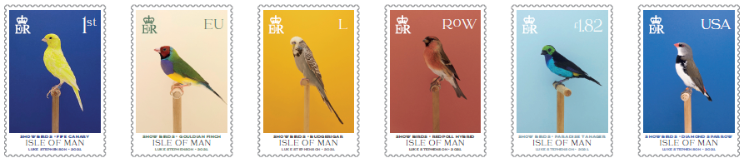

Isle of Man Post Office (IOMPO) presents a wonderful set of six stamps of both, popular and unusual species of birds selected from the world of cage and aviary as seen through the lens of photographer Luke Stephenson. The set of six stamps is to be issued on 9th February 2021.

The birds selected are new to the IOMPO stamp collection and include both common and exotic varieties and hybrids to illustrate an important aspect of bird fancying, that of creating cross breeds, both for their appearance and song.

Local designer Emma Cooke of EJC Design has created a beautiful and vibrant set of six stamps utilising the photography of Luke Stephenson, who has spent a number of years photographing the varied species of birds featured upon the stamps. This distinctive style poses the exhibited bird affront a vibrant and decorative background, contrasting with the colour of the bird’s plumage. The following species are featured upon the stamps; The Fife Canary, Gouldian Finch, Budgerigar, Redpoll Hybrid, Paradise Tanager and the Diamond Sparrow.

Jerwood Photography Prize winner Stephenson’s work has been published in a variety of publications including The New York Times Magazine, The Guardian, Dazed & Confused, Foam, Art Review and Wallpaper. He has exhibited his photographs most notably at The Photographer’s Gallery in London and has published three books to date: An Incomplete Dictionary of Show Birds, 99x99s (about the classic ice cream) and The English Rose.

Photographer Luke Stephenson, said: It’s a great honour to have my work displayed on stamps and be among many great artists that have done so in the past. It seems very fitting that my images of birds will now literally be flying around the world.

Maxine Cannon, General Manager Isle of Man Stamps & Coins, said: It’s been a pleasure working with Luke on this stamp collection. The stamps give a glimpse into the world of show birds and his stunning photographs meticulously capture the beauty of these charming creatures. We’d also like to thank Roy Howarth, Andy Sykes and Tina Jauncey for their expert assistance in the creation of this unique stamp issue.

The Show Birds collection is available as a Set and Sheet Set, Presentation Pack and First Day Cover. For further information, please visit www.iompost.com/showbirds.
-ENDS-
Technical Details
Text: Luke Stephenson, Roy Howarth,
Images: Luke Stephenson
Design: EJC Design
Printer: Cartor
Process: Offset Lithography
Colours: 4 colour
Paper: 110 gms PVA gummed
Perforations: 13 per 2cms
Stamp Size: 42 x 28mm
No. of Stamps: 6
Format: Sheets of 20
Date of Issue: 9th February 2021

NOTES TO EDITOR

- For images of the stamps, please visit here
- Attachment 1: Issue Text
- Attachment 2: Stamp Set
- Attachment 3: Presentation Pack
- Attachment 4: First Day Cover
- Photographer and Issue Text Author Luke Stephenson: Luke was born on New Year’s Day, 1983 in Darlington, North East England. Life in Britain and the British psyche are at the core of Luke’s work. He photographs what, to many, epitomises the eccentricity of Britain. Often humorous in their outlook, his series range from prize budgerigars to The World Beard and Moustache Championships. Whether animate or inanimate objects, Stephenson creates affectionate portraits of his subjects and documents worlds often hidden from the mainstream. He graduated in 2005 and has worked as a freelance photographer since. The same year he was awarded the Jerwood Photography Prize and in 2006 was selected as one of ten photographers to showcase their work at the International Festival of Fashion and Photography at Hyeres, France. His work has been published in a variety of publications including The New York Times Magazine, The Guardian, Dazed & Confused, Foam, Art Review and Wallpaper*. Luke has published three photo books to date, his first was a series of Show Birds published in 2012 and the second published in 2014 is a series exploring the wonderful world of the 99 ice cream. Most recently in 2019 he produced a book looking at the beautiful English rose. www.lukestephenson.com
- Acknowledgements: We are grateful to Roy Howarth, Andy Sykes and Tina Jauncey for their expert assistance.
- Get the latest Isle of Man Stamps and Coins news at www.facebook.com/IsleofManStampsandCoins
- Keep up-to-date with the latest news on Twitter: @IOMstampscoins
- Isle of Man Stamps and Coins is proud to be accredited and partnered with various organisations.

Issued by Nicole Livingston, PR, Communication and Social Media Executive, Isle of Man Post Office
Tel: 01624 698 471 Email: nicole.livingston@iompost.com

Sales & Marketing  Phone: +44 (0)1624 698 437  Mobile: +44 (0)7624 497 248  Email – Maxine Cannon  maxine.cannon@iompost.com | Customer Services  Phone: +44 (0)1624 698 430  Fax: +44 (0)1624 698 434  Email: stamps@iompost.com  www.iomstamps.com  Office hours: Monday to Friday 8.30am to 5pm GMT

