Date: 10th December 2020

Isle of Man Post Office Writes Postal History Issuing First Ever Triangular Stamps by any British Postal Administration

Chinese Year of the Ox is Celebrated on Triangular Set of Stamps

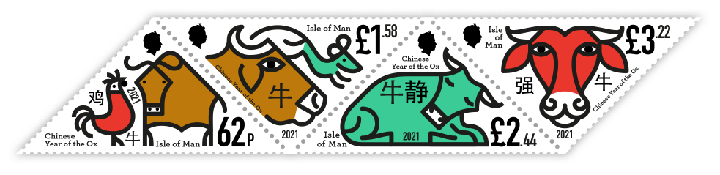

Isle of Man Post Office celebrates the Chinese New Year with a set of four stamps designed by Manx illustrator and artist Jay Cover.

The Chinese New Year or Spring Festival is one of the most widely celebrated annual festivals on the planet. 2021 marks the year of the Ox, the second animal within the twelve year cycle or the Zodiac. According to legend the Chinese zodiacs’ order was chosen by the Jade Emperor through a race. Rat and Ox travelled together and struck up a deal: Ox would carry Rat while Rat would sing for him. Just as they got to the finish line Rat jumped off and came in first.

The four stamps valued at 62p, £1.58, £2.44 and £3.22 are the first triangular stamps from any of the British postal administrations (Royal Mail, the Channel Islands and Isle of Man).

The uncommon design was first issued by the Cape of Good Hope on 1st September 1853 and are generally referred to as the ‘Cape Triangulars’. The Cape Legislative Council determined that it wanted a ‘device so different from those of English postage stamps as to catch the eye at a glance’.

Richard West MBE, Fellow of the Royal Philatelic Society enthusiastically commented “Even more unusual is the fact that two of the stamps have the apex of the triangle at the base of the design. Most triangular stamps are designed with the apex at the top of the stamp, printed in sheets with alternate stamps upside down (known as ‘tête-bêche’), an arrangement successfully overcome in this case.”

Artist Jay Cover, said: “For the illustrator creating a stamp design for your country is like being an athlete competing in the Olympic Games. Not only that but to do so in such an innovative way, by creating Britain’s first triangular stamp and to celebrate the Chinese New Year speaks to our Island’s global outlook, our openness our desire to embrace other cultures. It’s an absolute privilege as always to work with Isle of Man Post Office and I’m eternally grateful to them for giving me the opportunity.”

Maxine Cannon, General Manager Isle of Man Stamps & Coins, said: “We are very proud to be able to issue the first ever triangular stamps from a British postal administration and are ever so grateful for the support and expertise of issue text author Richard West. We also would like to thank Jay Cover; his unique and delightful designs form the perfect focal point for this extraordinary stamp shape.”

‘The Chinese Year of the Ox’ collection is available as a Set and Sheet Set, a 62p Value Stamp Sheet, Presentation Pack (limited to 1500) and First Day Cover (limited to 2250). There will also be a limited numbered edition of 100 Imperforate Sheetlets available. For further information, please visit www.iompost.com/ox.

-ENDS-
Technical Details
Text: Richard West MBE
Design: Jay Cover
Printer: Cartor
Process: Offset Lithography
Colours: 4 Spot Colours
Paper: 110 gms PVA gummed
Perforation Gauge: 12.598 x 12.47 x 12.47 per 2 cms
Stamp Size: 63.5 x 44.9 x 44.9 mm
Format: Sheets of 20
Date of Issue: 7th January 2021

NOTES TO EDITOR

- For images of the stamps, please visit here
- Attachment 1: Issue Text
- Attachment 2: Stamp Set
- Attachment 3: Photograph Jay Cover
- Attachment 4: Photograph Richard West MBE
- Richard West MBE: Richard has been a stamp collector since he was eight years old, being Editor of the monthly Stamp Magazine from 1972 until 1999. He is a member of the Royal Mail Stamp Advisory Committee, is a Fellow of the Royal Philatelic Society London, and has been heavily involved for many years with encouraging the young to collect, including being an international judge. He was honoured with the MBE for Services to Philately in 2012.
- Jay Cover: Manxman, illustrator and artist Jay Cover lives and works in Hastings, England. After studying Foundation Art and Design in 2000 at The Isle of Man College under Ian Coulson, Jay moved to Yorkshire to study BA Visual Communication at Leeds College Of Art, where he spent nine years getting to know his craft, whilst forming an artist collective, Nous Vous. In 2011 Jay moved to London where, alongside his illustration practice, he took a job as an associate lecturer at Camberwell College of Arts, where he worked for five years. More recently in want of a ‘quieter life’ and a desire to reconnect with the sea, he relocated to the south coast of England to work from a home studio where he focusses on his illustration practice. Jay paints and makes sculptures in his spare time.
Jay continues to work for a global client base on a large variety of projects, notably producing animated adverts for Facebook and Cheerios, beer labels for Camden Town Brewery, books for Princeton Architectural Press and Tate Publishing and promotional campaigns for The Southbank Centre and The Green Man Festival

- Chinese New Year: In more recent years a number of postal administrations have marked the Chinese New Year with a special stamp release. As far as the People’s Republic of China is concerned, the first occasion was in 1980 when, on 15th February, an 8 fen stamp marked the Year of the Monkey. The design, by Huang Yongyu and Shao Bolin, showed the Gēngshēn Monkey or Golden Monkey. Although 5 million were printed, it is a sought-after stamp of which forgeries have been produced.

- Get the latest Isle of Man Stamps and Coins news at www.facbook.com/IsleofManStampsandCoins
- Keep up-to-date with the latest news on Twitter: @IOMstampscoins
- Isle of Man Stamps and Coins is proud to be accredited and partnered with various organisations. For more information please visit here.
Issued by Nicole Livingston, PR, Communication and Social Media Executive, Isle of Man Post Office
Tel: 01624 698 471 Email: nicole.livingston@iompost.com

Sales & Marketing  Phone: +44 (0)1624 698 437  Mobile: +44 (0)7624 497 248  Email – Maxine Cannon  maxine.cannon@iompost.com | Customer Services  Phone: +44 (0)1624 698 430  Fax: +44 (0)1624 698 434  Email: stamps@iompost.com  www.iomstamps.com  Office hours: Monday to Friday 8.30am to 5pm GMT

