Date: 27th October 2020

Isle of Man Post Office Issues The Story of the Nativity on Christmas Stamps 2020

6 Stamps Share a Collection of Beautifully Presented Artworks Depicting the Religious Story of the Nativity

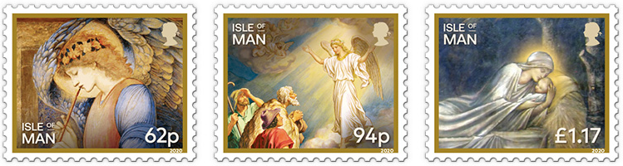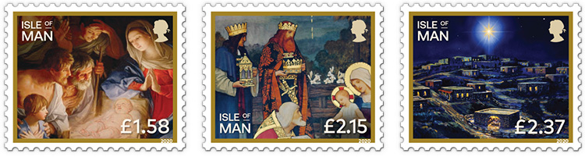

This year’s Isle of Man Post Office Christmas stamps, issued on 30 October, feature scenes and artworks inspired by the story of the Nativity.

2020 marks the 40th anniversary of the consecration of the Cathedral Isle of Man. It is the cathedral church of the Church of England Diocese of Sodor and Man and was made a cathedral by Act of Tynwald in 1980. To commemorate this anniversary the Right Reverend Peter Eagles, Bishop of Sodor and Man kindly provided the issue text for this beautiful stamp collection.

Issue Text Author the Rt Revd PA Eagles, Bishop of Sodor and Man, said: "These delightful Christmas stamps point to light and hope. The angel speaks of God’s presence in the world, and the simple shepherds are drawn to God’s light and love. Three Kings worship, representing the nations of the world. The light shines in the darkness, and the Mother cradles the Child in profoundest love. The eternal message of Christmas speaks to us today in these six beautiful designs."

Nigel Godfrey, Dean of Cathedral Isle of Man, said: ‘It is good to have a stamp issue released on the 40th birthday of the Island’s Cathedral. The Cathedral was actually built a 100 years earlier to replace the ruined one on St Patrick’s Isle, but the driving force behind it - Bishop Rowley Hill died in office before the necessary legislation was passed by Tynwald, so it simply remained a parish church. The Cathedral as the ‘seat’ of the Bishop aims to offer the daily round of worship to God and serve the needs of our ever changing world.’

Maxine Cannon, General Manager Isle of Man Stamps & Coins, said: “Christmas stamps help deliver festive messages of good cheer and celebration across the Island, the UK and around the world. This year’s stamps feature scenes from the Nativity. They are intended to remind us of blessings received throughout this difficult year and to give us a bit of tradition during these uncertain times.”

‘The Story of the Nativity’ collection is available as a Set and Sheet Set, Presentation Pack and First Day Cover. To celebrate the 40th anniversary of the Cathedral Isle of Man there will be a limited edition philatelic numismatic cover (PNC) featuring a £5 Peace Coin along with the stamps and photography of the Cathedral provided by Simon Park. The stamps will also be available as variable value self-adhesives (VVD). These will be vended via our retail kiosks, post office counter network and via hand-held vending machines at one-off events such as stamp exhibitions. For further information, please visit www.iompost.com/nativity

-ENDS-
Technical Details
Text: The Rt Revd PA Eagles
Design: Glazier Design
Printer: Lowe-Martin
Process: Offset Lithography
Colours: 4
Paper: 110 gms PVA gummed
Perforations: 13 per 2cms
Stamp Size: 32 x 26mm
No. of Stamps: 6
Format: Sheets of 25
Date of Issue: 30th October 2020

NOTES TO EDITOR

- For images of the stamps, please visit here
- Attachment 1: Issue Text
- Attachment 2: Stamp Set
- Attachment 3: Presentation Pack
- Attachment 4: First Day Cover
- Attachment 5: Peel Cathedral 40th Anniversary PNC
- The Diocese of Sodor and Man is the smallest diocese in the Church of England, but one of the very oldest. Christianity was brought to the Isle of Man by St Patrick, and the Island’s first bishop was recorded in the year 447. It is thus a Celtic diocese within the Church of England. It also has significant history from the period of the Norse hegemony in the twelfth century, including Tynwald, ‘the world’s oldest continuous parliament’. The Bishop of Sodor and Man is a member of Tynwald and sits weekly in the Legislative Council throughout the parliamentary year. The Diocese now consists just of the Isle of Man: the ‘Sodor’ (‘Southern Isles’ or Latin Sodorensis, being the Hebrides, as opposed to the ‘Nordor’ of Shetland and Orkney) now belong to the Scottish Episcopal Church, but the Manx Diocese retains its ancient title. Bishop Peter has been in post since September 2017, and his task is to lead, enable and resource clergy and parishes in their care of our people, in addition to representing the Isle of Man to the international Christian Church and to the wider world.
- 2020 has been declared the ‘Year of Cathedrals and Pilgrimage’ by the Association of English Cathedrals
- About Variable Value Definitive Variable rate definitive self-adhesive stamps' are known as 'Post & Go stamps' and 'Faststamps' in a number of other jurisdictions. They are popular, highly collectable and viewed as the next generation of self-adhesive stamps. Each stamp features the stamp value, date of issue, sequential number and stamp identifier.

- Get the latest Isle of Man Stamps and Coins news at www.facbook.com/IsleofManStampsandCoins
- Keep up-to-date with the latest news on Twitter: @IOMstampscoins
- Isle of Man Stamps and Coins is proud to be accredited and partnered with various organisations. For more information please visit here.
Issued by Nicole Livingston, PR, Communication and Social Media Executive, Isle of Man Post Office
Tel: 01624 698 471 Email: nicole.livingston@iompost.com

Sales & Marketing  Phone: +44 (0)1624 698 437  Mobile: +44 (0)7624 497 248  Email – Maxine Cannon  maxine.cannon@iompost.com | Customer Services  Phone: +44 (0)1624 698 430  Fax: +44 (0)1624 698 434  Email: stamps@iompost.com  www.iomstamps.com  Office hours: Monday to Friday 8.30am to 5pm GMT

