Date: 10th August 2020

Master Watchmakers of the Isle of Man Commemorated on a Set of Six Stamps

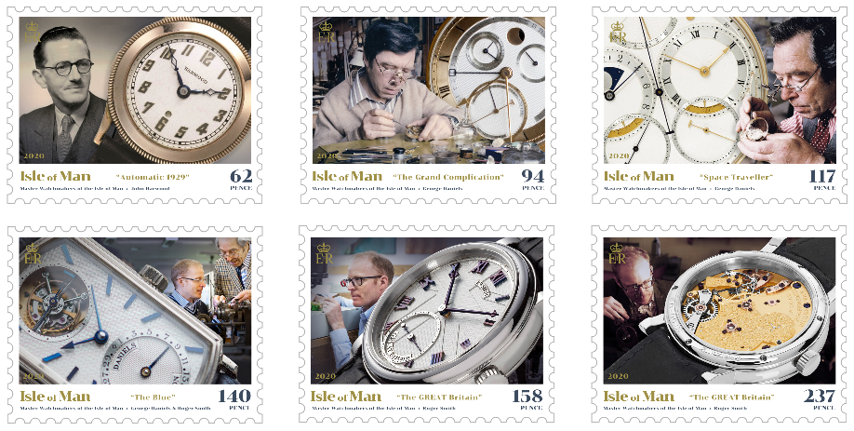

Isle of Man Post Office takes great pleasure in issuing this landmark set of stamps on 11th August 2020, showcasing three remarkable master watchmakers who are inextricably linked to the Isle of Man.

The Isle of Man is a nation regarded by many watchmakers and enthusiasts alike, as the country of origin for some of the finest watches and timepieces in the world. Three extraordinary talented British master watchmakers, John Harwood, George Daniels and Dr. Roger W Smith OBE, who called the Isle of Man their home, and their luxurious timepieces are being displayed on this remarkable set of six stamps.

John Harwood (1893–1964) settled on the Isle of Man after returning from the trenches of the First World War to work in a tiny Douglas workshop repairing wristwatches. It was here that he invented the first self-winding wristwatch for which he was awarded a patent in 1924. His 1929 model ‘The Automatic’ was produced on the Isle of Man and is depicted on the 62p stamp.

One of the greatest watchmakers of the modern era, George Daniels (1926-2011), had his breakthrough with the invention of the co-axial escapement, ultimately resulting in increasing the efficiency of the mechanism. It is considered by many to be the most important development in horology in 250 years. Sotheby’s London sold Daniels’s ‘Space Traveller’s Watch I’ in 2019 for the staggering sum of £3,615,000 making it one of the most expensive watches ever sold. The author of ‘Watchmaking’ and several other books is depicted on two of the six stamps and shares a third one of them with Dr. Roger Smith OBE, who wrote the issue text for this collection.

Roger Smith’s horological career began, aged 16, at the Manchester School of Horology. He graduated top of his class and was awarded the British Horological Institute’s Bronze Medal, which is awarded to the most outstanding graduating student of any given year. During the course, Dr. George Daniels, attended as a visiting speaker and inspired Roger’s ambition to hand-make watches. After eventually working alongside Dr. Daniels to create the Millennium Series of watches, Roger established his own studio in the Isle of Man in 2001. Carrying on the legacy of the Daniels Method of watchmaking with his own individual style, over the years Roger Smith has been recognized by receiving numerous awards and honours including the Barrett Silver Medal and was also awarded an OBE in 2018. In 2019, Smith announced a collaboration with Manchester Metropolitan University to develop the world’s first mechanical watch using nano-materials.

Roger W Smith OBE, said “I am delighted to have contributed to this fascinating stamp issue by the Isle of Man Post Office. It reminds us not just about the achievements of John Harwood and George Daniels, but also the Isle of Man as a very special place in the pantheon of horological invention”.

Maxine Cannon, General Manager Isle of Man Stamps & Coins, said: “We are proud to be able to showcase another facet of our Island with this landmark stamp issue. It is incredible to think that some of the horological society’s most highly rated master watchmakers were connected to the Isle of Man in such an inextricable way. Our gratitude goes out to Roger W Smith OBE and Alastair Audsley whose contributions and support were invaluable in the creation of this stamp issue.”

The ‘Master Watchmakers of the Isle of Man’ collection includes a set of six stamps, a Presentation Pack, a First Day Cover, a Sheet Set and a special 28 page Prestige Booklet and can be ordered from www.iompost.com/watchmakers.

-ENDS-

Technical Specifications
Issue title: Master Watchmakers of the Isle of Man
Text: Alistair Audsley, Roger Smith, Mike France and Nicholas Manousous
Design: Isle of Man Advertising
Printer: Cartor
Process: Offset Lithography
Colours: 4 colour plus varnish
Paper: 110 gms PVA gummed
Perforations: 13 per 2cms
Stamp Size: 52mm x 40mm
No. of Stamps: 6
Format: Sheets of 12
Date of Issue: 11th August, 2020

NOTES TO EDITOR
- For images of the stamps, please visit this link.
- Attachment 1: Issue Text
- Attachment 3: Set, Sheet Set, Presentation Pack, First day Cover and Prestige Booklet
- About the issue text author Roger Smith OBE: Roger Smith’s horological career began, aged 16, at the Manchester School of Horology. He passed out top of his class and was awarded the British Horological Institute’s Bronze Medal. During the course, Dr George Daniels (1926-2011), was a visiting speaker and inspired Roger’s ambition - to hand-make watches. After eventually working alongside Dr Daniels to create the Millennium Series of watches, Roger established his own studio in the Isle of Man in 2001. His first creation was the Series 1 watch followed, in 2006, by his seminal Series 2. In 2012, the British Horological Institute recognised Roger with the rarely-awarded Barrett Silver Medal. During 2013, Roger was invited by the Prime Minister, David Cameron to become an Ambassador for the GREAT Britain campaign, representing the best of British innovation, technology and creativity. To celebrate these values, Roger created the now iconic ‘Great Britain’ watch. In 2015, Roger Smith announced the first range of authentic British watches for decades. The range comprises reimagined Series 1 and 2 watches, newly developed Series 3 and 4 watches and the Series 5 (Open Dial) watch. All feature Roger’s latest evolution of his single-wheel co-axial escapement. In 2018, Roger was awarded the Order of the British Empire (OBE) for ‘outstanding services to watchmaking’ and, in 2019, Birmingham City University awarded Roger an honorary doctorate in recognition of his advancements in horology. In 2019, at the ‘Designing Our Future’ expo in New York City, Roger announced his collaboration with the Faculty of Science at Manchester Metropolitan University to develop the world’s first mechanical watch using nano-materials. Named the ‘GREAT Britain II’, this watch represents the greatest single step forward for mechanical watch technology in the modern era.
- About issue researcher Alistair Audsley: Having grown up in the Isle of Man, Alistair was educated to post-graduate level at the London Institute. Returning to the Island he embarked on a successful career as an advertising creative director, founding Solus in 1999. Alistair also began a parallel career as an award-winning screenwriter and film producer, with international cinema releases as well as Netflix, SKY and Amazon. Since 2009 he has consulted for worldrenowned watchmaker Roger W. Smith and, in 2012, co-produced the feature documentary ‘The Watchmaker’s Apprentice’ (director Dave Armstrong) which traced Dr Smith’s early career with Dr George Daniels. In 2019 Alistair was appointed an Ambassador for the UK Government’s GREAT Britain campaign in recognition of his creative contribution to projects such as Roger Smith’s seminal watch, The GREAT Britain, art installations by Roger Dean and Andrew Hall and as lead producer of the “Star Wars - Made GREAT in Britain” series of films. He is a founder and strategic adviser to the Alliance of British Watch and Clockmakers, a new trade body established to support the resurgence of Britain’s watchmaking sector. Alistair’s other major film producing and writing credits include: “Stronger Than Bullets” (director Matthew Millan), “The Green Hell” and “Silent Night - A Song for the World” (director Hannes Schalle). Alistair is married with three children. He is a former track athlete and gold medallist in 100 metres in the 1995 and 1997 International Island Games.
- Get the latest Isle of Man Stamps and Coins news at www.facbook.com/IsleofManStampsandCoins
- Keep up-to-date with the latest news on Twitter: @IOMstampscoins
- Isle of Man Stamps and Coins is proud to be accredited and partnered with various organisations. For more information please visit here.

Issued by Nicole Livingston, PR, Communication and Social Media Executive, Isle of Man Post Office
Tel: 01624 698471 Email: nicole.livingston@iompost.com

Sales & Marketing  Phone: +44 (0)1624 698 437  Email – Maxine Cannon  maxine.cannon@iompost.com  Office hours: Monday to Friday 8.30am to 5pm GMT | Customer Services  Phone: +44 (0)1624 698 430  Fax: +44 (0)1624 698434  Email: stamps@iompost.com  www.iomstamps.com

