Date: 26th April 2021

Celebrating 10 Years of Marriage
Congratulations to their Royal Highnesses the Duke & Duchess of Cambridge

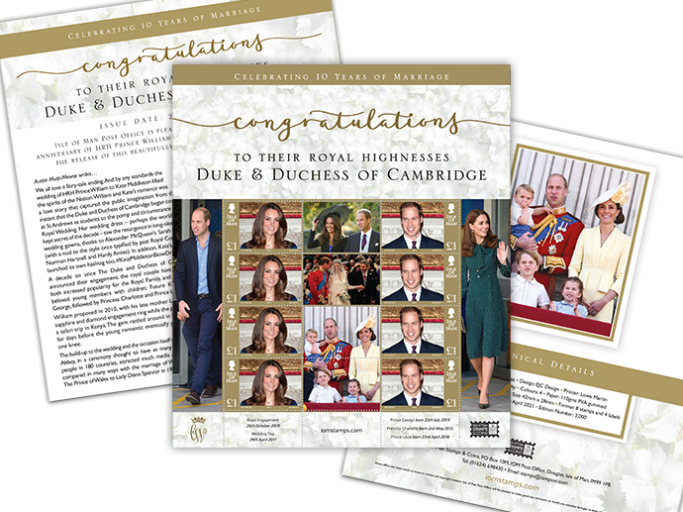

Isle of Man Post Office commemorates the 10th wedding anniversary of HRH Prince William and the Duchess of Cambridge during a time that can only be described as difficult for the Royal Family, mourning the loss of HRH Prince Philip the Duke of Edinburgh.

This beautifully presented commemorative sheetlet (limited edition of 3000 worldwide) was designed by local designer Emma Cooke of EJC Design and features the happy couple during various stages of their relationship and as a family. The decorative border surrounding the stamps provides the key dates relating to the happy couple, such as the date of their engagement, their wedding day, and the birth dates of each of their three adoring children: HRH Prince George, HRH Princess Charlotte and HRH Prince Louis.

Maxine Cannon, General Manager Isle of Man Stamps & Coins, said: “I remember back in 2011 when William and Kate married it was the most beautiful day here on the Island as we sat down to watch the wedding. I bought a specially produced William and Kate tea service, and like so many toasted to the very good health and happiness of the newly-weds. As they celebrate their “Tin” wedding anniversary, where a diamond is the traditional gift, it’s very fitting as they and their three young children have brought a sparkle to the Royal Family. Yes I still have the Tea Service!”

The sheetlet will be issued on 29th April 2021 and will be limited to 3000. For more information visit www.iompost.com/royal-collections.
-ENDS-
Technical Details
Text: Austin Mutti-Mewse
Design: EJC Design
Printer: Lowe Martin
Process: Offset Lithography
Colours: 4
Paper: 110gms PVA gummed
Perforations: 13 per 2cm
Stamp Size: 42mm x 28mm
Format: 8 stamps and 4 labels
Date of Issue: 29th April 2021
Edition Number: 3,000

NOTES TO EDITOR

- Attachment 1: Sheetlet
- Attachment 2: Issue text
- Attachment 3: Press Release Word Document
- Price per sheetlet £9.00
- Issue text author Austin Mutti-Mewes: We have relied on Austin’s royal expertise for various royal stamp issues in the past. A published author, he is currently working on a new book on his experiences as a teenager in Hollywood during the early 1990s. Austin resides in Surrey with his wife Joanna and young son Nathan.
- Get the latest Isle of Man Stamps and Coins news at www.facebook.com/IsleofManStampsandCoins
- Keep up-to-date with the latest news on Twitter: @IOMstampscoins
Issued by Nicole Livingston, PR, Communication and Social Media Executive, Isle of Man Post Office
Tel: 01624 698 471 Email: nicole.livingston@iompost.com
Sales & Marketing  Phone: +44 (0)1624 698 437  Mobile: +44 (0)7624 497 248  Email – Maxine Cannon  maxine.cannon@iompost.com | Customer Services  Phone: +44 (0)1624 698 430  Fax: +44 (0)1624 698 434  Email: stamps@iompost.com  www.iomstamps.com  Office hours: Monday to Friday 8.30am to 5pm GMT

