Date: 18th January 2019

ISLE OF MAN POST OFFICE REJOICES AT THE ADVENT OF THE YEAR OF THE PIG

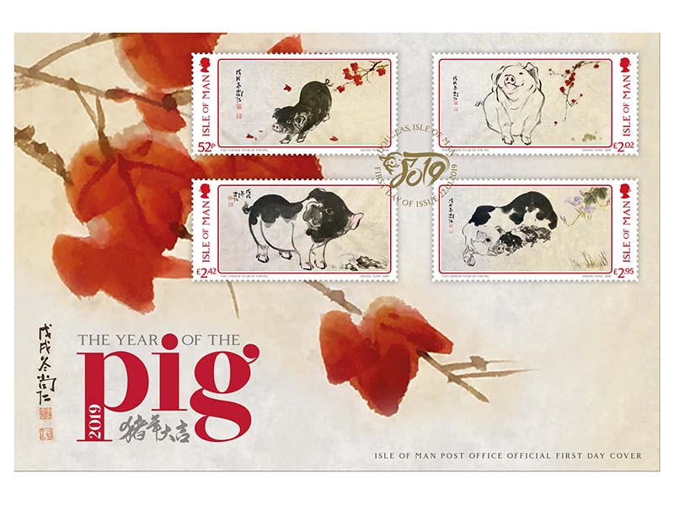

On January 22nd the Isle of Man Post office will issue a set of 4 stamps, beautifully painted by artist Zhang Yong, to celebrate the Year of the Pig in the Chinese Zodiac Calendar.

The years of the Chinese calendar follow a 12-year cycle and each year is associated with one of 12 animal symbols (rat, ox, tiger, rabbit, dragon, snake, horse, goat, monkey, rooster, dog and pig). Every New Year marks the end of the reign of one animal and the beginning of the next. Those born under the sign of an animal are thought to possess the qualities associated with it.

Pigs are the symbol of wealth and fortune. People born in the year of the pig are attributed with being energetic and always enthusiastic. They are realistic and though they are not wasteful spenders, they are said to enjoy life and treat themselves occasionally.

The Chinese New Year, or Spring Festival is the longest holiday of the year in China and has a history of more than 4000 years. Specific activities and traditions will be celebrated each day. Celebrations start on February 4th, which marks the actual New Year’s Eve in the Chinese calendar. The traditional Spring Festival itself commences on February 5th till February 15th. February 16th till 18th are preparation days in the build-up for the Lantern Festival which will peak on February 19th 2019.

Zhang Yong’s ‘courtesy name’ is Shangren. Since childhood, Shangren was tutored in Chinese painting under Mr Luo Jintang, an artist of the Lingnan school of painting and a cultural relics expert in Guangdong Province. Later, he was taught by Mr Ye Quan, a famous Lingnan painter. Shangren is currently a member of the Guangdong Youth Artists Association, a member of the Guangdong Collectors Association and is the distinguished artist of the Studio of Political Consultative Conference of Guangzhou Haizhu District.

Maxine Cannon, General Manager, Isle of Man Stamps and Coins said: "We are proud to present this special stamp issue in conjunction with the Naughton Group and Artist Zhang Yong. Following up on last year’s Year of the Dog collection, celebrating the Spring Festival with our Chinese friends has become a tradition that commemorates the relationship between the Isle of Man and China.

In addition to the four-piece set a First Day Cover and a Presentation Pack are now available for pre-order at www.iompost.com/pig.

TECHNICAL DETAILS

Images: Zhang Yong
Concept & Text: The Naughton Group
Design: EJC Design
Printer: Lowe Martin
Stamp Size: 60 x 30mm
Colours: 5
Process: Offset Lithography
Perforations: 13.3 per 2cms
Paper: 110 gms PVA Gummed
No. of Stamps: 4
Format: Sheets of 20
Issue Date: 22nd January 2019

Notes to Editor:
- Attachment 1: Q&A Zhang Yong
- Photo1: Zhang Yong
- Photo2: Dominic Naughton & Zhang Yong
We are very pleased to work with The Naughton Group, a Hong Kong-based graphic design and marketing company set up by Dominic Naughton in 1995 with whom we collaborated on our Year of the Snake stamp issue in 2001. Over the years the company has had offices in Shanghai, Singapore and Malaysia. The company provides a wide range of design services to a broad range of clients all over Asia.
- IOMPO offers a ‘no quibble’ return policy, free worldwide delivery and aims to despatch an order within 24 hours by First Class post (Monday to Friday). For more information about IOMPO’s stamp collection or delivery policies, customers can visit IOMPO’s website www.iomstamps.com
- Keep up-to-date with the latest news on Twitter: @IOMstampscoins
- Please visit our Media Centre where you can freely download copy, latest news, copyright free and approved images http://www.iompost.com/media-centre/login/

Issued by Nicole Livingston, PR, Communication and Social Media Executive, Isle of Man Post Office

Tel: 01624 698471 Email: nicole.livingston@iompost.com
Sales & Marketing  Phone: +44 (0)1624 698 437  Email – Maxine Cannon  maxine.cannon@iompost.com  Office hours: Monday to Friday 8.30am to 5pm GMT | Customer Services  Phone: +44 (0)1624 698 430  Fax: +44 (0)1624 698434  Email: stamps@iompost.com  www.iomstamps.com

