Date: 18th June 2020

125th Anniversary of the Snaefell Mountain Railway Commemorated with Stamp Issue

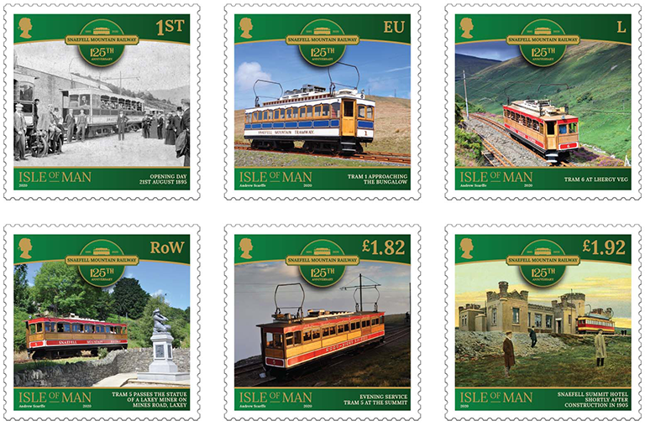

Isle of Man Post Office will issue a brand new set of six stamps on 25th June 2020 to celebrate the 125th anniversary of the first mountain railway in the British Isles.

The Snaefell Mountain Railway climbs from Laxey to the summit of Snaefell, the Isle of Man’s only mountain, 2036 feet above sea level. Built by pioneering Victorian engineers, its trams were powered by electricity, a technology then very much in its infancy. Very few British cities or towns had electric trams at this time; an electric tramway climbing a mountain was without doubt state of the art technology. Perhaps even more remarkable, the railway is still in active operation today and is little changed from those Victorian times.

A journey from Laxey to the summit takes thirty minutes. As the trams climb the Laxey Valley there are unrivalled views of the Laxey Wheel and the hamlet of Agneash. At Lhergy Veg, the line clings to a steep rock face looking down on the Laxey River far below. Trees and lush farmland are left behind as the landscape gradually changes to that of the more barren uplands. The Mountain Road is crossed at the Bungalow and the line now climbs in a spiral around the mountain. In turn Sulby Valley, Jurby, the Point of Ayre and Ramsey come into view before the tram comes to a halt outside the Summit Hotel. A short walk takes the traveler to the actual summit from where, on a clear day England, Scotland, Wales, Northern Ireland and Ireland can be seen.

Issue text author Andrew Scarffe, Isle of Man Railways, said: “It was a great privilege to be asked to provide the images for the stamps which will be issued to celebrate the 125th anniversary of the Snaefell Mountain Railway in 2020. The commemorative stamps are a fitting tribute to the skill of the pioneering Victorian engineers responsible for the railway’s construction. I hope that these stamps will encourage people to travel on and enjoy this unique railway.”

Maxine Cannon, General Manager, Isle of Man Stamps & Coins, said: “We would like to thank Isle of Man Transport for their assistance in the preparation of this stamp issue. To be “on board” with Andrew Scarffe has been a great journey. His insight, passion and lifelong interest in the Snaefell Mountain Railway has proven to be invaluable in the creation of this wonderful collection.”

The ‘Snaefell Mountain Railway: 125th Anniversary’ collection includes a set of six stamps, presentation pack, first day cover and sheet set and can be ordered from www.iompost.com/snaefell.

Technical Specifications
Issue title: Snaefell Mountain Railway: 125th Anniversary
Text: Andrew Scarffe
Design: EJC Design
Printer: Lowe Martin
Process: Offset Lithography
Colours: 4 colour plus varnish
Paper: 110 gms PVA gummed
Perforations: 14 per 2cms
Stamp Size: 40mmx 40mm
No. of Stamps: 6
Format: 12 stamps per sheet
Date of Issue: 25th June, 2020

ENDS
NOTES TO EDITOR
- For images of the stamps, please visit this link.
- About issue text author Andrew Scarffe has had a lifelong interest in the Manx Electric Railway and Snaefell Mountain Railway. His earliest memories are of weekly trips on the tram to Ramsey to visit his grandparents. While still at school, Andrew began to research the history of the Great Laxey Mine which led to the publication of his first book, a definitive history of the mine and the Laxey Wheel, which was published in 2004 to mark the 150th anniversary of the waterwheel. Since then he has written a further six books about various aspects of the history of Laxey and the railways. His latest book tells the history of the Snaefell Mountain Railway to mark its 125th anniversary. Andrew has been a volunteer on the Great Laxey Mine Railway since it was opened in 2004 and took on the role of fundraiser for the restoration of the former Snaefell waterwheel, which was restored in 2006. He has been a committee member of the Laxey and Lonan Heritage Trust for 15 years and was recently elected chairman. He regularly gives illustrated talks about the railways and mine. He now works for the engineering department of Isle of Man Railways and can often be seen driving the electric trams of the Manx Electric Railway during the summer months.
- Get the latest Isle of Man Stamps and Coins news at www.facbook.com/IsleofManStampsandCoins
- Keep up-to-date with the latest news on Twitter: @IOMstampscoins
- Isle of Man Stamps and Coins is proud to be accredited and partnered with various organisations. For more information please visit here.

Issued by Nicole Livingston, PR, Communication and Social Media Executive, Isle of Man Post Office
Tel: 01624 698471 Email: nicole.livingston@iompost.com

Sales & Marketing  Phone: +44 (0)1624 698 437  Email – Maxine Cannon  maxine.cannon@iompost.com  Office hours: Monday to Friday 8.30am to 5pm GMT | Customer Services  Phone: +44 (0)1624 698 430  Fax: +44 (0)1624 698434  Email: stamps@iompost.com  www.iomstamps.com

