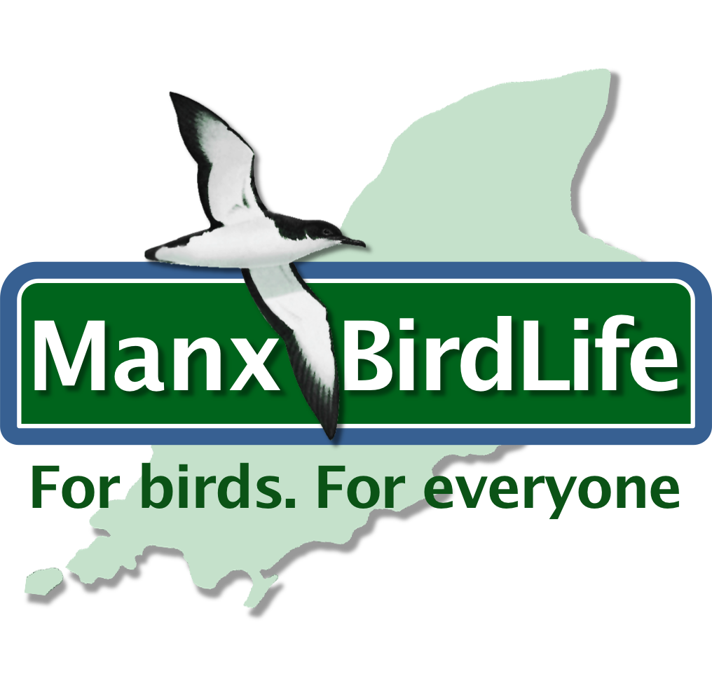
Date: 9th September 2019

Isle of Man Post Office and Manx BirdLife Recognise Research Programme of Breeding and Wintering Birds on the Island

Spectacular Illustrations by Local Artist Jeremy Paul Featured On Stamp Collection
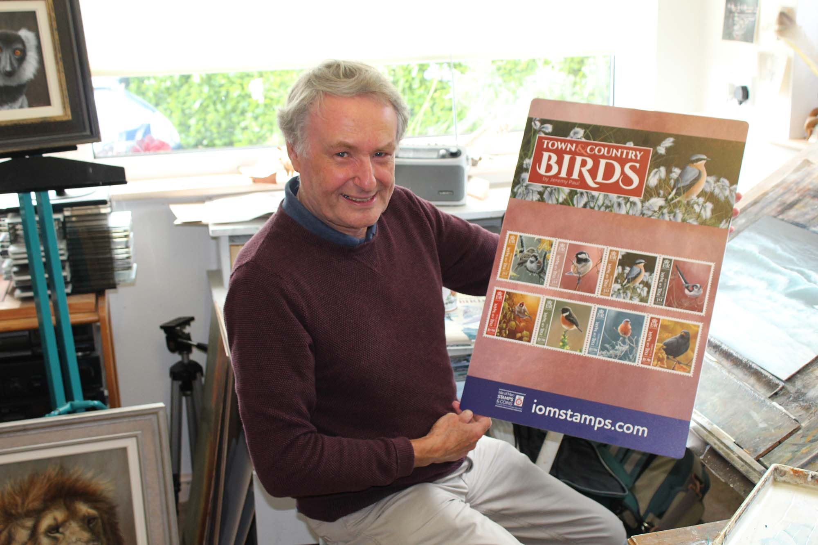

In April 1998 local ornithological research and conservation charity ‘Manx BirdLife’ was officially formed to undertake the ambitious project of protecting the Island’s wild birds and their natural environment.
To celebrate the important conservation work of the ‘Manx BirdLife’ census the Isle of Man Post Office will issue “Town & Country Birds”, a set of eight stamps on 19th September, 2019, featuring the work of renowned local wildlife artist Jeremy Paul.

This beautiful collection recognises and celebrates the importance of the research by featuring eight birds that breed on the Isle of Man, all of which can readily be seen and enjoyed throughout the Island: House Sparrow, Coal Tit, Wheater, Long-tailed Tit, Stonechat, Chaffinch, Blackbird and Goldfinch.

In conjunction with the launch of this stamp collection Jeremy Paul will be presenting 30 new paintings at Isle Contemporary in Tynwald Mills. The exhibition ‘Wildlife – An artist’s view’ will open on Sunday, 29th September until November 3rd and is a fantastic opportunity to see Jeremy’s stunning pieces of art live and up close.

Artist Jeremy Paul said: “As a professional wildlife artist, I have been fortunate in being able to see some spectacular wildlife around the world, from tigers in India to polar bears in the Arctic. However, I still get as much pleasure simply watching local wildlife and the birds I see out of my studio window so I am delighted to have them on this series of stamps.”
Maxine Cannon, General Manager, Isle of Man Stamps and Coins said: “It is our duty to protect the Island’s wildlife and birds along with the habitats on which they depend. We are honoured to be working with Manx BirdLife in recognising the importance of the research programme of breeding and wintering birds and we are ever so grateful to Jeremy Paul, whose breathtaking illustrations are once more showcased on our stamps.”

The ‘Town & Country Birds’ collection is available as Set and Sheet Set, Presentation Pack and First Day Cover. For further information, please see www.iompost.com/birds.

TECHNICAL DETAILS

Images: Jeremy Paul
Text: Chris Sharpe
Printer: Lowe Martin
Designer: EJC Design
Stamp Size: 40 x 40mm
Colours: 4
Process: Offset Lithography
Perforations: 14 per 2cms
Paper: 110 gms PVA Gummed
No. of Stamps: 8
Format: 4 of each value over 2 Sheets of 16
Issue Date: 19th September 2019

NOTES TO EDITOR
- Photo embedded and attached of: Jeremy Paul (Artist)
- Further attachments: Set, Sheet Set, First Day Cover and Presentation Pack
- Text attached: Issue Text with detailed information
- Manx BirdLife is a conservation charity based in the Isle of Man working to protect the Island’s wild birds and the habitats on which they depend. Since 1997, they have monitored the abundance and diversity of the Island’s wild birds. They use this data to inform conservation action that creates a better future for birds and people. Their goal is to ensure that future generations can continue to enjoy and cherish the Island’s wonderful natural heritage. By continuing to undertake surveys and censuses, and through best practice conservation projects and education initiatives, they believe the future can be bright.
- Artist Jeremy Paul was born in Accrington, Lancashire, Jeremy has lived on the Isle of Man for many years. He originally trained as a marine biologist and is completely self-taught, the essence of his work being the accurate portrayal of wildlife in its environment. He works in acrylics, developing the painting in many layers; under-painting and glazing to alter the tone and atmosphere of the work aspiring to capture a moment in time, creating a sense of quiet stillness in which wild birds or animals are seen, undisturbed by the viewer – a forgotten corner of a barn, a peaceful riverbank – small cameos which are pictures of tranquillity. Jeremy has won awards for his work including Wildscape Artist of the Year 2008, BBC Wildlife Artist of the Year - Category Winner 2010, 2011, 2012 and the British Wildlife Award at the National Exhibition of Wildlife Art 2015.
- For further pictures please visit our Media Centre where you can freely download copy, latest news, copyright free and approved images http://www.iompost.com/media-centre/login/

Issued by Nicole Livingston, PR, Communication and Social Media Executive, Isle of Man Post Office
Tel: 01624 698471 Email: nicole.livingston@iompost.com

Sales & Marketing  Phone: +44 (0)1624 698 437  Email – Maxine Cannon  maxine.cannon@iompost.com  Office hours: Monday to Friday 8.30am to 5pm GMT |   Customer Services  Phone: +44 (0)1624 698 430  Fax: +44 (0)1624 698434  Email: stamps@iompost.com  www.iomstamps.com

