Date: 12th August 2019 

ISLE OF MAN POST OFFICE AND THE ROYAL AERONAUTICAL SOCIETY COMMEMORATE A CENTURY IN TRANSATLANTIC AVIATION

THE HISTORY OF TRANSATLANTIC AVIATION PORTRAYED IN ART DECO STYLE STAMP COLLECTION

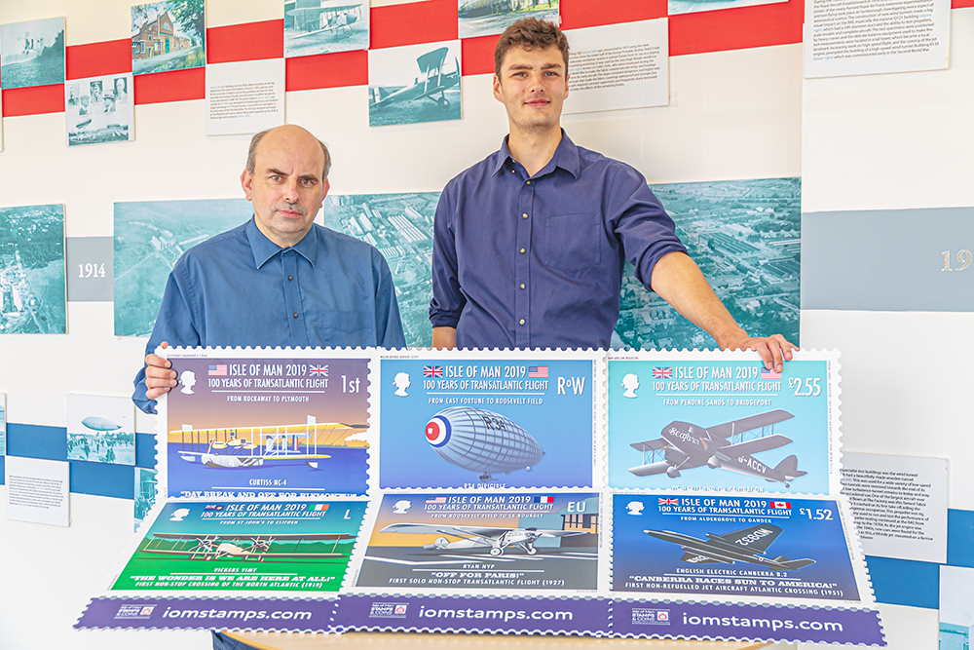

The Isle of Man Post Office is proud to commemorate a century of achievement in transatlantic aviation to be issued on August 20th 2019. The Art Deco Style stamp collection, created by Glazier Design, showcases the aircraft of the first crossings of the Atlantic in 1919 and a selection of the most significant crossings since.
In April 1913 the London newspaper The Daily Mail offered a prize of £10,000 (the equivalent value of over £ 510,000 in 2019) to "the aviator who shall first cross the Atlantic in an aeroplane in flight from any point in United States of America, Canada or Newfoundland to any point in Great Britain or Ireland in 72 continuous hours". Due to the outbreak of World War I in 1914 the competition was suspended but after Armistice was declared in 1918 the race was back on.
On 14th June 1919 pilot John Alcock and navigator Arthur Whitten-Brown flew their Vickers Vimy, featured on the Large Letter stamp, in less than 16 hours from St. Johns, Newfoundland to Clifden, County Galway in Ireland and were awarded the Daily Mail prize. Two weeks earlier the Curtis NC-4 (featured on 1st class stamp), a United States Navy flying boat flew from Trepassey Bay, Newfoundland to Lisbon, completing the first crossing of the Atlantic Ocean by air. However, this flight was not eligible for the Daily Mail prize since it wasn’t non-stop and took more than 72 consecutive hours. Many further attempts followed of which some of the most notable and significant crossings have been captured in this beautiful and stylish stamp collection.
In April 1933 world-renowned woman aviator and pilot Amy Johnson and her then-husband, Jim Mollison visited the Isle of Man. During their stay, Amy Johnson planted a tree in Glen Helen which to this day is commemorated with a plaque in the Manx Glen. Later that year Johnson and Mollison were scheduled to fly from South Wales to New York which almost ended in disaster when a shortage of fuel resulted in a crash landing in Bridgeport, Connecticut. The £ 2.55 value stamp is dedicated to their plane ‘Seafarer’, a de Havilland DH.84 Dragon.
Further stamps feature the ‘Ryan NYP’ flown by Charles Lindbergh (EU value), the R34 Dirigible under the command of Major G. H. Scott (RoW value) and the English Electric Canberra B.2 piloted by RAF Squadron Leader A.E. Callard (£1.52 value).

“The pioneering marathon flights in which the Atlantic Ocean was crossed by flying boat, airship and landplane must have seemed daunting at the time but opened the gateway for future long-distance air travel, thereby ‘shrinking’ the world,” said Sir Brian Burridge, CEO of the Royal Aeronautical Society. “These historic events are more than worthy of commemoration, we are only too glad to assist with this project.”

Ben Glazier of Glazier Design in London said: “We were thrilled to design the 100 Years of Transatlantic Flight stamps. We took our idea and inspiration for the collection from the 100th anniversary of Alcock & Brown's flight. We chose to celebrate the exploits of the pilots, including their achievements in the intricate details of the stamps. Our illustrator created artistic interpretations of long-lost aircraft deriving style from the Art Deco aviation posters of the 1920s, marking another great centenary.”

Maxine Cannon, General Manager, Isle of Man Stamps and Coins said: “The early stages of transatlantic aviation and the pioneering spirit of those involved allow us to travel the way we do today. We feel honoured to be able to commemorate this centenary and we are very proud to be working with Brian Riddle of the National Aerospace Library at the Royal Aeronautical Society and Glazier Design on this stylish and chic stamp collection.”

The ‘100 Years of Transatlantic Flight’ collection is available as Set and Sheet Set, Presentation Pack and First Day Cover. For further information, please see www.iompost.com/aviation.

Technical Details
Text: Brian Riddle, Benedict Glazier
Design: Rory Peters, Glazier Design
Printer: LM Group
Process: Offset Lithography
Colours: 4
Paper: 110gms PVA gummed
Perforations: 14 per 2cms
Stamp size: 50 x 42mm
No. of Stamps: 6
Format: 12 stamps per sheet
Date of Issue: 20th August 2019

NOTES TO EDITOR
- Photo embedded and attached of: Brian Riddle (Issue Text) & Rory Peters (Designer).
- Further attachments: Set, Sheet Set, First Day Cover and Presentation Pack
- Text attached: Issue Text with detailed information
- Pictures of Brian Riddle and Rory Peters were taken at the National Aerospace Library of the Royal Aeronautical Society in Farnborough, where boards of the stamp collection are currently showcased.
- The Royal Aeronautical Society is the world’s only professional body dedicated to the entire aerospace community. The Society promotes the highest professional standards in all aerospace disciplines; provides specialist information; acts as a central forum for the exchange of ideas; and plays a leading role in influencing opinion on aerospace matters. For more information about the Royal Aeronautical Society visit www.aerosociety.com.
- For further pictures please visit our Media Centre where you can freely download copy, latest news, copyright free and approved images http://www.iompost.com/media-centre/login/

Issued by Nicole Livingston, PR, Communication and Social Media Executive, Isle of Man Post Office
Tel: 01624 698471 Email: nicole.livingston@iompost.com

Sales & Marketing  Phone: +44 (0)1624 698 437  Email – Maxine Cannon  maxine.cannon@iompost.com  Office hours: Monday to Friday 8.30am to 5pm GMT |   Customer Services  Phone: +44 (0)1624 698 430  Fax: +44 (0)1624 698434  Email: stamps@iompost.com  www.iomstamps.com

